CS3D661: Individual Project – Computer Science (2017/2018)

The Development of Software to help teach Mathematics to Primary School Children

Produced By

Nicholas Grahame M. Flint

15008134

Supervised By

Prof Andrew Ware

Secondary Supervisor

Dr Emlyn Everitt

# Statement of Originality

## CS3D660 Individual Project

This is to certify that, except where specific reference is made, the work described within this project is the result of the investigation carried out by myself, and that neither this project, nor any part of it, has been submitted in candidature for any other award other than this being presently studied.

Any material taken from published texts or computerized sources have been fully referenced, and I fully realize the consequences of plagiarizing any of these sources.

Student Name (Printed): Nicholas Grahame M. Flint

Student Signature: N. Flint

Registered Course of Study: BSC (Hons) Computer Games Development

Date of Signing: 20/04/18

Abstract

Within this project, it is shown that interactive media, in the form of video games can be used to assist in the education of mathematics for school children. In addition to the basic mathematics, such as addition, subtraction, multiplication, and division; video games can help provide a resource to improve knowledge on a wide range of the national curriculum. This project aims to explore the concept of gamification and its growing impact within the classroom and how verbal games for learning along with the increasing access to technologies being given to schoolchildren on a daily basis are helping towards the development and inclusion of game-based learning. The initial investigations show the correlation between bright colours and imagery to help keep children engaged with learning, allowing game developers to explore a range of methods when developing for schoolchildren.

Table of Contents

Statement of Originality 2

CS3D660 Individual Project 2

Abstract 3

Chapter 1: Introduction 6

1.1 Project Statement 7

1.2 Project Objectives 7

Chapter 2: Literature review 8

2.1 Examples of Video Games being used for Education 12

Chapter 3: Implementation 14

Chapter 4: Initial prototyping 17

4.1 First Prototype Menu 17

4.2 Improved Prototype Menu 20

4.3 C++ Implementation 22

Chapter 5: Final Product 30

5.1 Initial Modifications to ‘Maths Challenge’ Asset 30

5.2 Addition, Subtraction, Division, Multiplication and Times Tables 31

5.3 Duplicate Correct Answers 31

5.4 Input Fields 31

5.5 Number Words 32

Chapter 6: Critical Evaluation 34

Chapter 7: Conclusions 36

7.1 Future Works 37

Chapter 8: Legal, Social, Ethical and Professional Issues 39

8.1 Legal 39

8.2 Social 39

8.3 Ethical 40

8.4 Professional Issues 40

Chapter 9: Appendices 41

9.1 Appendix 1 – Project Timeline 41

9.2 Appendix 1 – Proof of Permission for ‘Maths Challenge’ Asset 43

9.3 Appendix 2 – C++ Prototype Code 44

9.4 Appendix 3 - National Curriculum in England: Mathematics Programmes of Study 61

9.5 Appendix 4 - Minutes of Meetings 65

Chapter 10: Ethics Checklist 69

References 70

# Chapter 1: Introduction

Interactive media, in particular video games have been the centre of a debate for the better part of the recent decade. From the turn of the century there has been a dramatic increase with the amount of technology that is available on a daily basis, this rise has also found its way into education with a staggering amount of schools across the United Kingdom integrating devices such as tablets into their resources for study.

One of the drawbacks surrounding the use of video games within the classroom is the associated stereotypes around them from media sources. In some cases where video games can be seen as the cause for social problems such as anger and violence among its users, research has found that there is little to no correlation between them. In many cases, the use of technology within classes help to reduce the levels of discomfort and increase motivation as they can experience their learning in a way that is similar to how they would be at home.

This project records a sample of the various video games that are being developed with the purpose of education being the central point of interest. There are many approaches to how different companies are aiming to help find innovative ways to create a more engaging and enjoyable learning environment for schoolchildren.

A few of these include the modification of one of the world’s most popular video games, Minecraft, by an indie company set on helping to mould the next generation. They have now been acquired by the games owners in order to offer more resources to improve the quantity and quality of the experience. Other approaches include the use of web applications with vibrant colours and eye catching imagery to help provide a different approach to getting pupils to practise their knowledge in an entertaining manner.

When developing games for the use of education it is important to make sure that it is focused around education. Developing an educational game that both engages the user and motivates them to keep on playing is useless if it doesn’t help with their education. It is important that the user gains some level of knowledge from playing the game otherwise there is no point in using the application in the first place.

One way that will be tackled with this project to aim to keep students motivated is to provide them with a scoring system so they can keep track of their own progress on a particular section of mathematics, so they can see their improvements over time. Doing this along with having questions that are at the standard to which they should be learning, it is important to mention that this project aims to create software that can help as a learning aid to develop knowledge they should already be learning, not to be used as a tool to learn new information from.

## 1.1 Project Statement

The creation of software that can be used as a learning aid to help in the education of Key Stage 1 (Ages 5 to 7) children.

## 1.2 Project Objectives

* Gain an understanding of the Unity Engine and the tools that it has available.
* Design and develop software that is both entertaining for children while being educational.
* Have multiple sections to cover the majority of the KS1 curriculum for mathematics.
* Create a point system to award children who get the answers correct so that they can keep track on their progress on a section.
* Design the software to be visually appealing to schoolchildren.

# Chapter 2: Literature review

For a long time, many schools have adapted to using social games to help with the education of children. Many people have completed research to explore just what impact these games have on the development of the child's learning. However, a lot of the time it is argued whether video games and other forms of media would help or hinder the children’s education and motivation.

Technology has been found to have many benefits in assisting education, and in turn, help with keeping children motivated (Anderson, 2000). The use of technology in the classroom can change the way a student perceives the task being undertaken, making them more motivated to complete the work, increasing both efficiency and self-worth upon completion. Technology can be used to help diversify tasks (Heafner, 2016) allowing children to build on their prior knowledge and develop their understanding of the content.

In many ways, the computer could be considered as one of the essential tools that are of daily access in modern society. If so, why would the children’s parents limit the opportunity available to play with them? Gray (2012) states that children are better at adapting to new situation than adults are, which is why when there is a new technology innovation children learn how to use it quicker than their parents do.

Some of the issues faced that make it difficult for games to be integrated into the national curriculum are; firstly being able to quickly determine whether the game is relevant and how accurate its content is (Kirriemuir & McFarlane Angela, 2006). Secondly the lack of time teachers may have to familiarise themselves with the game, to figure out the best way to use the game for active learning. And finally, the amount of content within the game that is irrelevant to the subject, that can't be ignored or removed, therefore resulting in a waste of valuable lesson time.

This does not stop many teachers and parents realising the potential valuable skills that can be developed from games (Kirriemuir & McFarlane Angela, 2006). For example: strategic thinking, planning, and communication, the application of numbers, negotiating, group decision-making and data handling. For some children, the instant and specific feedback given by games, help children to figure out a right way to succeed, with the element of competition or teamwork with their peers being motivational for children (Teed, 2016). This is leading to an increasing number of U.S. schools integrating video games into their curriculum as teachers can use them to help deliver core lessons, included but not limited to, math, reading and developing new skills such as computer programming (Malykhina, 2014). This gamification of education can lead to children developing technology skills that will help them to succeed in their academic and professional careers in an active form of learning.

One argument tackled by Miller (2011) is that game-based learning (GBL) is simply just using a game, whether it be physical or on the web, within the classroom. He States that game-based learning is taking a “rigorous unit of study” and making it into a game that goes in depth to explore the learning concepts, and not just for one day.

It has been found that pupil motivation is significantly higher when computer games are integrated into the educational process (Wastiau, et al., 2009). Children enjoy having a more concrete purpose to the work that is given as the approach of using computer games takes account of their everyday reality. The increase of motivation can be seen to link with the boost in self-confidence some children’s develop, which gives teachers the opportunity to help and guide less experienced children.

The four significant concerns surrounding video games and thus halting their potential to be used within the classroom are that violence and aggressive behaviour is seen to be caused by video games, they can “employ destructive gender stereotyping” (Squire, n.d.), promote unhealthy attitudes and hinder creative play. These views are reasonable as the majority of mainstream games have a plotline that is more or less “kill or be killed” and house themes that are inappropriate for the classroom. So far, research has found little to no relationship between the increase of aggressive behaviour and video games.

At Patrick Henry Elementary School, U.S., games are used both formally and informally to help children to connect to the curriculum through play (EducationWorld, n.d.). Prompting the principal, Marcia Baldanza to say “Children learn best when the content is relevant to them and when they can connect new learning with old.” EducationWorld.com has a list of a few websites that have access to games designed to enrich the learning of school children. These websites are exempt from ad pop-ups, as many young children “have trouble distinguishing between the ads and the games.” One of the key reasons that some schools have chosen to promote the use of educational games is that they help to encourage children to learn outside of the classroom (Teed, 2016). Video games are also useful for helping to bridge the “Digital Generation Divide”, as children growing up now have grown accustomed to very different technologies that their teachers had used while at school.

In an article by the Stanford News (Mackay, 2013) a panel discussion was held at the Graduate School of Education, U.S., which discussed "gaming to learn" a concept that was argued to have been around for close to a decade. However, it has only been recently that gamification's properties have been appreciated in education. It was argued that the use of games within education is not a matter of dumbing down the learning. Games are hard and are a medium that help to set minds free to help humans think better as part of a network. Steinkuehler (2013) , an associate professor of digital media at the University of Wisconsin-Madison, discussed that most Massively Multiplayer Online (MMO) games, which include a "system of points, badges, rewards, and leaderboards" can, in fact, be replicated within education to help with different people’s motivational needs for ‘interaction and self-expression. It is argued by Steinkuehler (2013) that not having access to games that teach the same amount of content than compared to books is not the problem for using games for education, and the problem is the approach to using them. With books, the students learn to read like a writer, with games that will not work as an approach is needed to be taken to allow them to play like a designer.

Children in “grade 3” in the U.S. learn that an island is “a piece of land surrounded by water on all sides” however this formal definition is absent from creativity (Mubaslat, 2012), leaving little or nothing to the imagination. A story told by a teacher, with descriptions slowly building up an image of what an island is will help children to have a clearer picture, as well as leaving room for them to populate their image with whatever their imagination sees fit. Creative learning through video games is a vast difference to having children sit for hours, listening to what the teacher says.

Active learning allows the children to experience the curriculum in more creative ways. A similar example to this is when secondary school children perform experiments in science classes. It is effortless for a teacher to stand at the front of the class and describe how a chemical reaction works, but allowing the children to witness it for themselves by actively undergoing the experiment, and changing measurements to see how that changed the outcome will help to get the information they are learning to sink in more. Both ways are learning within the classroom; however, the experiments are also allowing them to be more creative in their learning as compared to reading and copying from a textbook.

GlassLab (the Games and Learning Assessment Lab) is responsible for some of the most significant research on game-based learning. They design and implement “game-based formative assessments” in response to the current issue of student disengagement that exists within the classroom (Sharpiro, 2014). Game-based learning can be used as an effective tool to provide a more contextualised active learning experience. D’Angelo, et al., (2014) conducted a study which, the results, show that games don’t need to include “gold coins or badges” to motivate players. The reason for this is because there is a distinct difference between gamification and game-based learning. The game does not need to be necessarily competitive, as the achievement lies with the “learning and understanding” (Sharpiro, 2014). The results from SRI are ‘hardly surprising’ as a survey from the Joan Ganz Cooney Center (2016) found that “55 percent of children play games at least weekly and 78 percent reported using games in the classroom at all.” (Korbey, 2014). Of the teachers that were surveyed, 47 percent said low performing children were found to benefit from using games, whereas only 15 percent said that high performing children were also helping from playing games.

The bad reputation that is surrounding the “generation of gamers” is mostly “based on fear” (Sharpiro, 2014). This is based on news stories that surround games that make children “hyper, violent, stupid and anti-social.” Whereas games can help to “break down the boundaries between academic subjects.”

## 2.1 Examples of Video Games being used for Education

An example of video games that have been used within the classroom is BBC Bitesize, and the BBC created a website designed to help with the education of children, from Key Stage 1 all the way through to GCSE. For Key Stage 1, mainly maths, the games, and clips they have covered the U.K. curriculum, spanning numbers, shapes and movement, measurements and data handling (BBC Bitesize, 2017). BBC Bitesize has been designed to help the student with both schoolwork and for older children, exams (Wikipedia, 2017).

MinecraftEdu, a modified version of Minecraft created for classroom use (MinecraftEdu, n.d.), is an example of a mainstream video game that has been extensively developed and modified to help with classroom learning. Granted the game has not been developed for education by Mojang, the creators of Minecraft directly but by, TeacherGaming. MinecraftEdu licenses the game from Mojang for the explicit purpose of making the game more affordable and accessible to educational institutions worldwide and is currently in use by teachers in over 40 countries (TeacherGaming, 2017). This modified version of Minecraft was so innovative that Microsoft, who purchased Minecraft in 2014 for $2.5bn (Miller, 2014) have also acquired MinecraftEdu to produce Minecraft: Education Edition (Microsoft, 2017) and develop it further than they necessarily would have been able to before.

The aim for this is to bridge the gap between the researches into how video games can be used within the educational system, along with working on the examples that have been highlighted above. To work on both the functional aspects of each approach, as well as taking into account the problems that have been faced by each example to create a game that is both engaging for the student and is able to keep them motivated to not only keep on playing, but also helping to develop their learning and understanding while doing so.

Research that took place which has not been directly referenced. (MarketsAndMarkets, 2016), (Doran, 2016), (Herger, 2011), (Hocking, 2015), (Lavieri, 2015), (Lukosek, 2016), (Moursund, 2007), (Sakamoto, n.d.), (Smith & Queiroz, 2015), (Smith-Robbins, 2011), (Takeuchi & Vaala, 2014), (Thorn, 2016).

# Chapter 3: Implementation

To develop software that is aimed to help support school children with their learning of mathematics and have it work correctly, it is essential that this project follows the national curriculum. This is to make sure that the information presented to them is as accurate as possible to the knowledge they should already be gaining within the classroom. The expectation of the prototype is not to be used as a substitute to what students would be learning from their teacher(s) but to act as a learning aid to help students practise the knowledge they have already acquired in an engaging and fun way.

The way that the development of the prototype has been executed is to aim to produce a working version that exceeds the extent of learning that is required from the curriculum for the students. The aim of this is to cover everything that should be within each section, from here these sections will be divided into the year group that the learning is relevant towards and scaled either up or down in difficulty to comply with the knowledge that the students should already know.

An example of this is to produce the “Number Words” section, where a student is either given the numerical version or written spelling of a number, and they must answer which is the corresponding answer of the opposite version. Designing this to be tailored towards year two learning makes it easier to scale down to make it suitable for year 1 students. In year two the students are expected to “read and write numbers to at least 100 in numerals and words” as stated by the Department for Education (2014) within the “National Curriculum in England: Mathematics Programmes of Study.” Since year 1 students are only required to read and write to 20 in numerals and words, it makes sense to complete the whole list to 100 to fit with the year 2's level of learning and then to scale it down to 20 to fit with year 1's. Doing this will lessen the overall workload as the year 1 section will mostly be a copy of the year 2, but removing data that is not necessary for their learning.

The first significant drawback that was faced at the beginning of the project was being able to convert a familiar programming language (C++) into C# within Visual Studio so that it can be modified to work with Unity Engine’s systems. There is a sizeable difference between having a working version written in C# in Visual Studio compared to being able to have it work within Unity, despite the fact that they are the same programming language.

The reason for this is because Unity requires the use of, for example, buttons or text (input) boxes that can work with the code to function. Whereas in Visual Studio everything is done within a text-based window and it's as simple as using ‘cin >> variable' to add an input to assign a variable with data that can be used elsewhere.

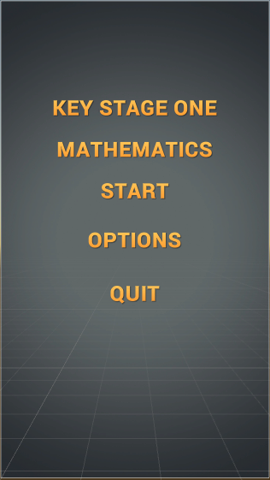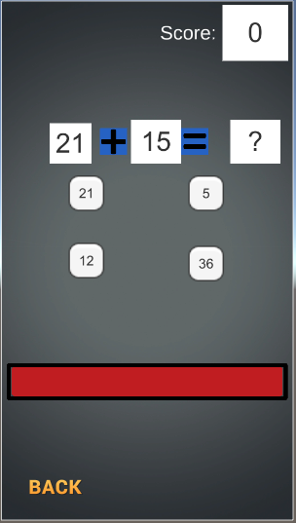

To develop the project to be tailored towards being used in schools, one thing that needs to be taken into account is how the students will use the application. As stated back in 2014 by Coughlan for BBC News Education a study found that “almost 70% of primary and secondary schools” across the U.K. have tablets available to use for education and “in 9% of schools, there was an individual tablet device for every pupil.” Because of this, the default aspect ratio of the application will be 16:9. Initially, the chosen ratio was 9:16 as many mobile devices and tablets support this ratio when used in a portrait orientation. However, 16:9 is supported on most tablet deceives and is native for laptops and computers, which are also technologies that children could have access to at home.

As a starting point to help with furthering the understanding of how to get text boxes and buttons to work in Unity along with the code an asset has been used from the Unity Store as a foundation for the addition, subtraction, division, and multiplication sections, this is because the asset has a lot of functionality that was pictured as the result of the prototype. For example, the asset can load the ‘Game Scene' and use the ‘Math Controller' it checks which math type the user has selected and then assigns the questions accordingly. Also depending on which math type is in use it changes the ‘mathSymbol' image to that math types corresponding expression. For each correct answer, the user gets one point, and an incorrect answer does not. Also when a correct answer is selected, it refills the timer bar, which dictates how long the student has to get an answer right, when the bar runs out the game is over.

Before taking the asset and building upon it, the developer of the asset was contacted, and they gave permission, which can be found in Appendix 1, for their asset to be used as a foundation for this project.

# Chapter 4: Initial prototyping

## 4.1 First Prototype Menu

One of the first problems that were encountered during the early development of this project is the lack of knowledge with the Unity Engine and the C# language. Because of this, the first step was to spend a few weeks getting used to the user interface of Unity. This was done by viewing tutorials that helped to lay out the key features and tools that Unity has to offer.

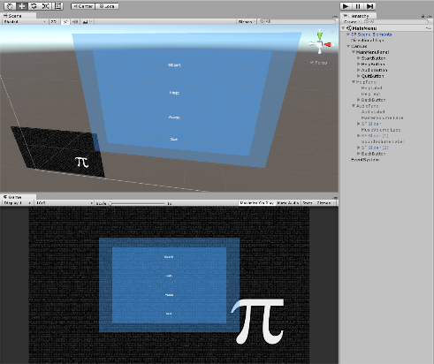

Due to the lack of video games that are being used within the classroom that was not developed with either Java or HTML, being able to look at the source code that is open to the public to view from indie companies is not much help for this project. This is because these programming languages and how they function are very different so that it would not be much use to help understand how their programs work to assist with developing in Unity.

From the research, it is apparent that the more common media form that is in use within classrooms are more of applications rather than games being used for education, more in particular applications based on tablet devices and the web. One of the similarities between the games includes the use of bright colours and a cartoonish approach towards the visuals. This will be taken into consideration towards the end of development after most of the functionality of the application has been implemented.

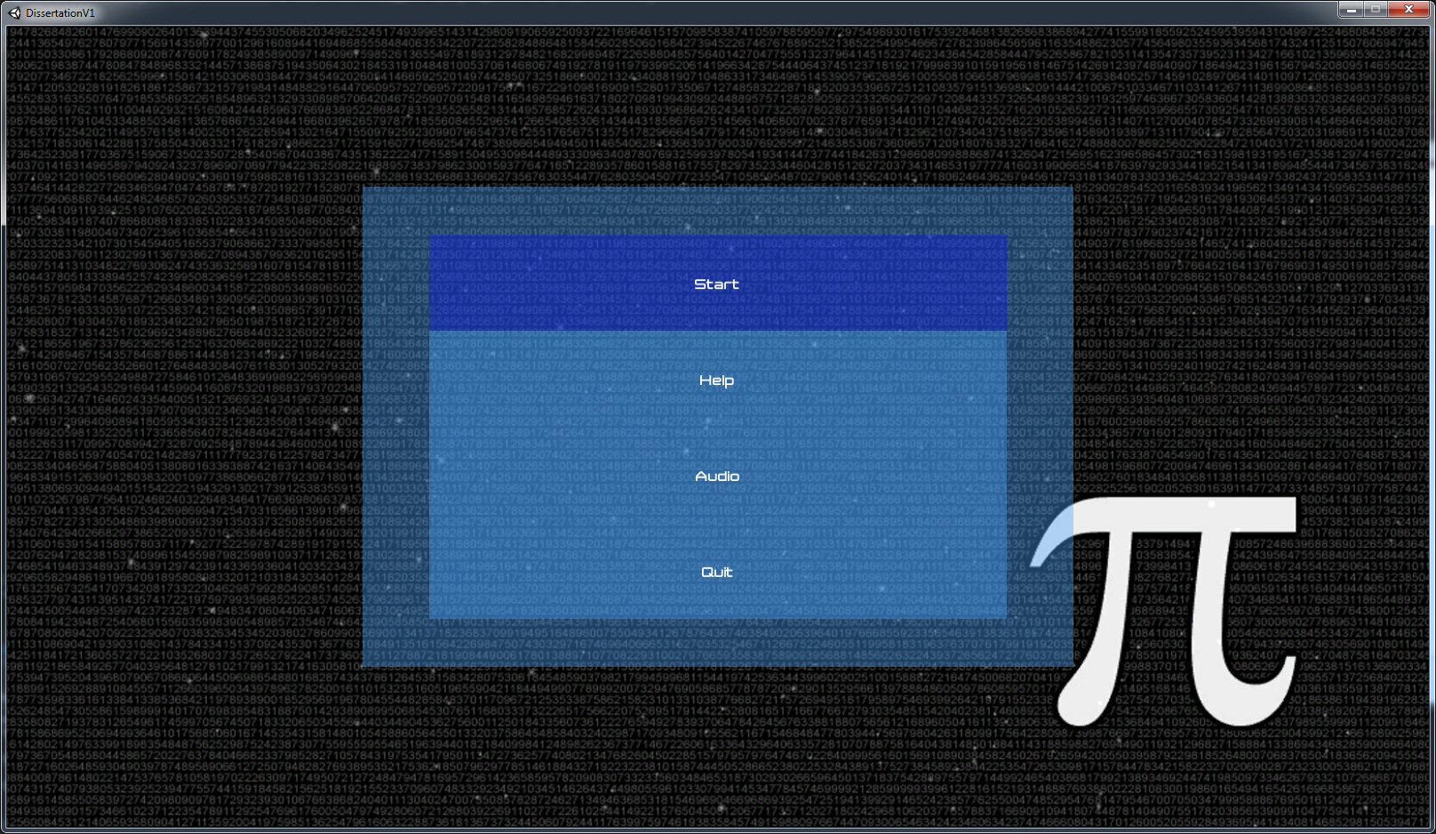

The first stage of experimentation with Unity was done following a tutorial that explained how to create a basic menu using Unity's UI canvas and panels. This tutorial only demonstrated how to make a simple main menu, but it did explain how to make it, so the buttons change colour, change to a different scene, quit the application and turn off one panel of the canvas and turn on another.

Each panel of the canvas represents a different layer of the menu, when the user hovers the mouse cursor over one of the buttons, the colour changes indicating the button that will be selected if they click the mouse. Additionally, this also works if the user is using the arrow keys to navigate the menu, the user can use the up and down keys to move and then use the enter key to select a button. When the user clicks the button the colour changes again and dims, indicating that they have chosen the button, the button's actions won't take place until the user has released the button, which also makes it change back to its original unclicked state before completing its assigned operation.

Within the first build it starts the user on the main menu, from here they can select the ‘Start', ‘Help', ‘Audio', and ‘Quit' buttons. The ‘Start’ button is set to load the next scene, which will be the game. The ‘Help’ button takes the user to the help screen, which currently contains a placeholder paragraph which will be changed later to a set of instructions to explain how each section of the application is meant to be used. The ‘Audio’ menu contains sliders that represent how the user will be able to change the levels of the audio of the application. The sliders can be used at the moment but with no effect happening. This will be made functional later on in development when sound is added to the program.

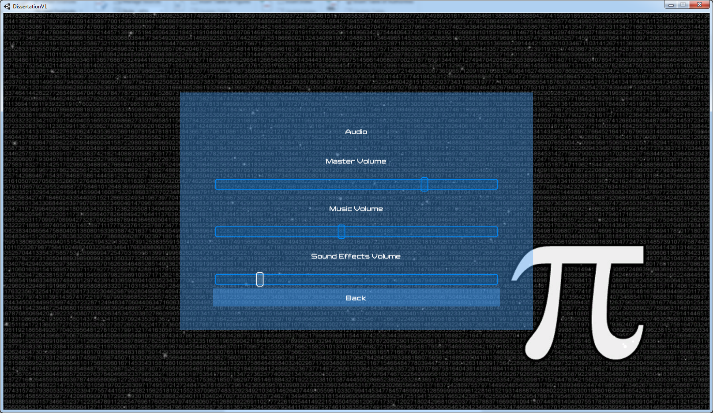

From these two menus, the user can select a ‘Back' button that will return them to the previous menu, at the moment that is the main menu as the system is only two layers deep. Later on in development, the user will be able to change the resolution of the application so that it can be best suited the user's preference and the device that it is being used. Another addition will be to allow the user to change the size of the text so that children to require larger or smaller text can use the application to best suit their needs. Towards the end of the development process, the menu systems visuals will be changed to in an attempt to make it more appealing towards young students. Additionally, a store could also be added so that the user can accumulate points from answering questions correctly to unlock different colour schemes and designs for the application. Hopefully giving more of a reason to continue their use.

The next stage of development is to add menu sections for years 1 and 2 of the Key Stage 1 curriculum. It is essential to have the parts separate to each other, while there are aspects that year 2 students will go over what they learned within year 1 they will go into more depth than they did in year 1. Additionally, it could confuse and upset a lot of students if they are being asked questions that they do not know the answer to, this is because year one students are not expected to have the same level of knowledge as those in year 2. After this, it will be important to have a detailed list of the types of questions that the children will need to answer so they can start to get implemented.

## 4.2 Improved Prototype Menu

The second variation of the menu removes the help sections as they will be added later on towards the end of development as the parts will need to be made so that useful information can be given to help the student with working on each section. The colour scheme of the application has also changed, changing to a grey gradient background with golden text on top, the sharp contrast of colours will make it easier for the user to read the text as compared to the previous white on blue.

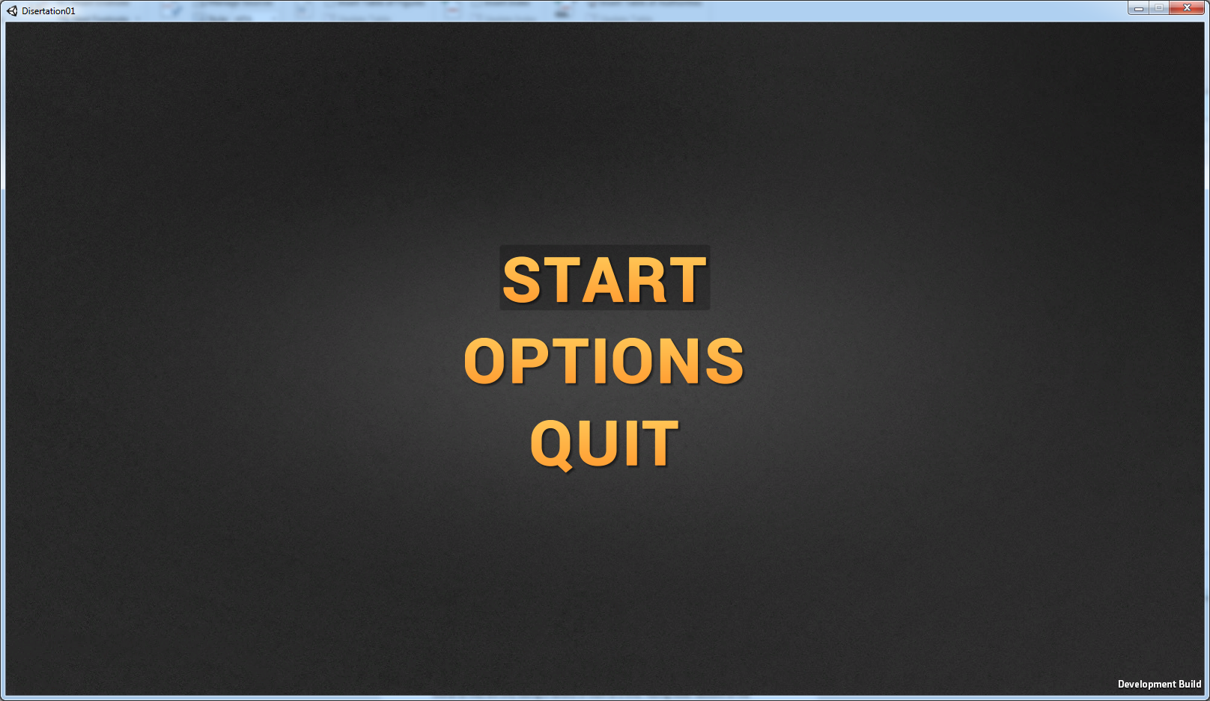

The options menu has been reduced so it only contains one slider to control the audio of the application with, once the sound is implemented. Having them condensed removes the cluttered feel of the options menu, and also allows more space if more options are going to be added later in development. Such as changing the resolution, switching to full screen and changing the size of the text. The handle for the slider has been removed to make it look sharper and more comfortable to see that the more that the bar is filled, the higher the audio levels will be.

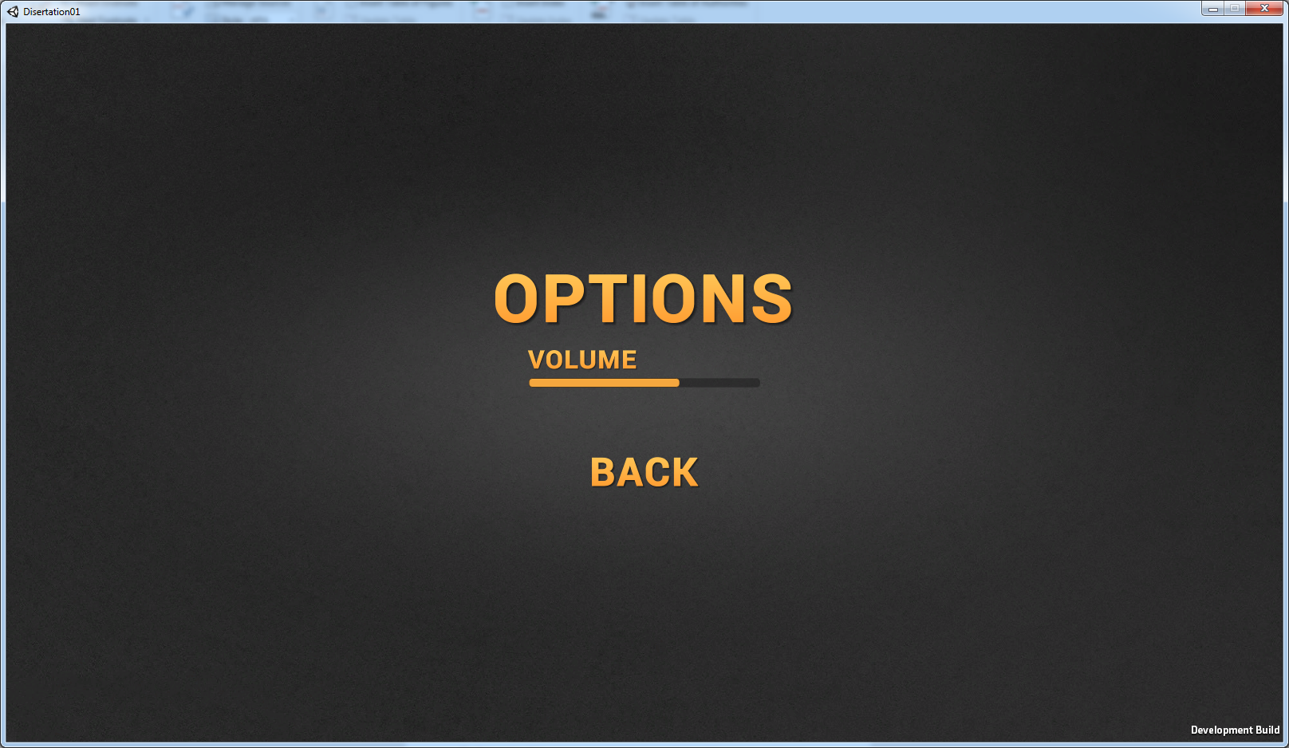

The first version of the category menu had also been added, and this menu is used to sort each of the different sections of the curriculum into their respective categories, making it easier for the student to find the part that they wish to practise. If all of the sections were placed on one screen, it would look cluttered and not be appealing to look at. This could make it harder for the pupil to find the part that they want to work on as they could be presented with around 20 different sections. This could be very daunting towards young students as it would seem that there are a lot more sections that they thought, reducing this to 7 to 8 per category could also make them feel that they have fewer parts to work though overall as they are only seeing a handful of them at a time. Having fewer sections on the screen at a time will also make it easier to read the titles of the categories so they can find the section they want to work on faster.

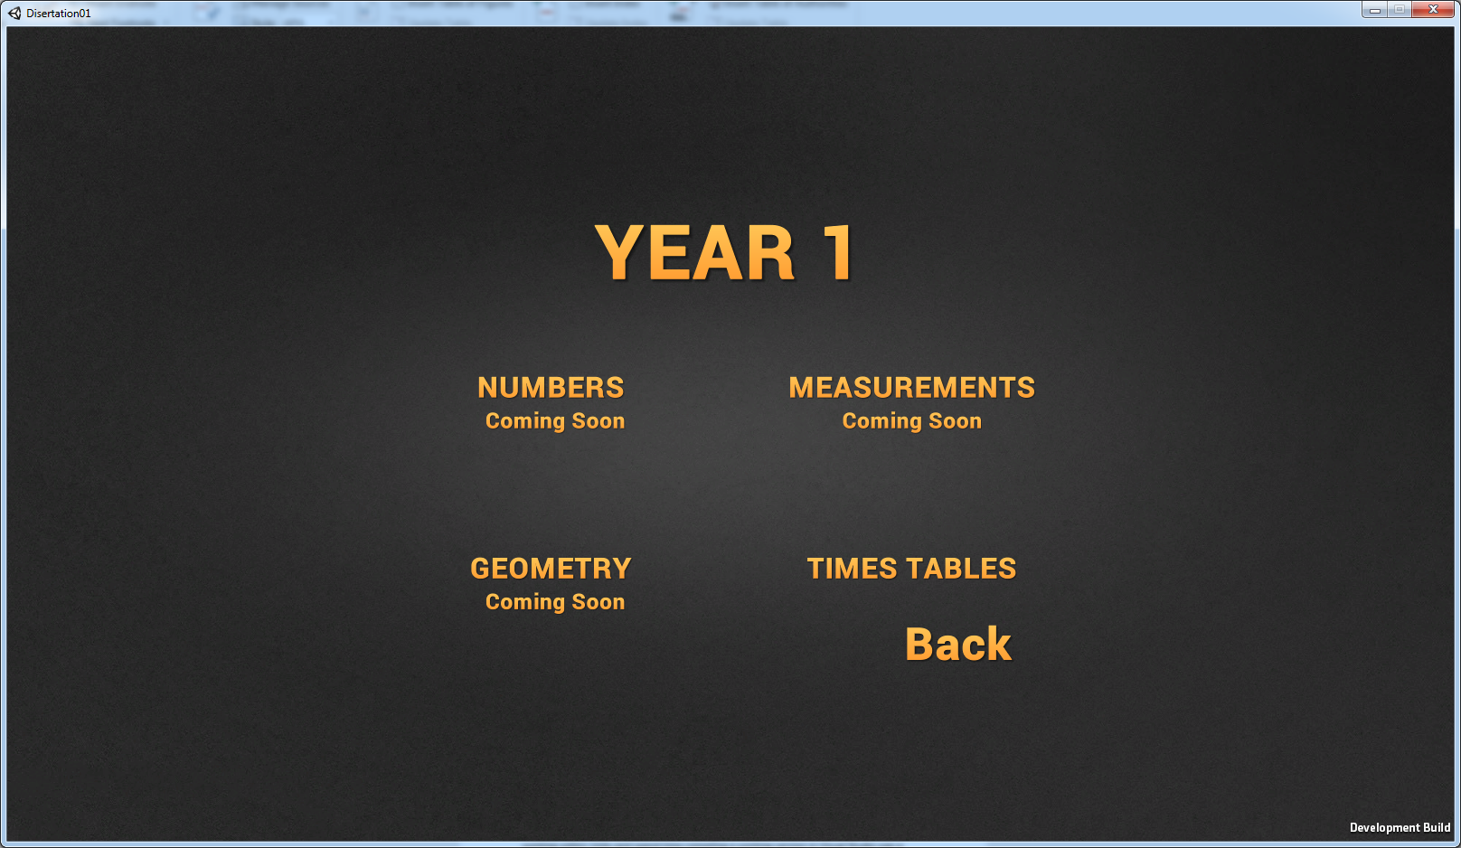

## 4.3 C++ Implementation

One of the recurring problems that were apparent during the development process was the lack of knowledge with using C#, especially within Unity. This made it quite difficult to have a starting point to go about creating the questions that would be asked for the children to answer. Because of this, the decision was made to create a version of the project in Visual Studio in C++, the code for which is available in Appendix 2, despite the fact that this version is text-based only, it helped to give a clear understanding of just how asking the questions should be done.

The only problem with this approach is the fact that since it is text-based, it will not be very appealing towards students. But it was an excellent start to get the understanding of how the final prototype would be expected to function. The decision to take a step back from working within Unity and spend time compiling a working version in Visual Studio was a difficult one to make, but after weighing up the pros and cons, it was viable to take time and dedicate it to get a working version. The downside of this was that time was being taken away that could have been spent working on the application and getting familiar with Unity. However, having a limited understanding with C# in the first place would have taken longer to get to grips with how to tackle implementing the questions.

Already having an understanding of C++ allowed time to be saved as this provided a visual representation of how the code should be laid out, the only step after this was being able to convert it to C# and using Unity’s systems. But overall this provided a strong tool that helped to speed up later developments. This prototype is designed to be tougher than would be required of the students, mainly because it is not a version that will be tested on the students, but also so that a further understanding of how to ask the questions to a more considerable extent which can be scaled accordingly to correspond to the requirements of the curriculum.

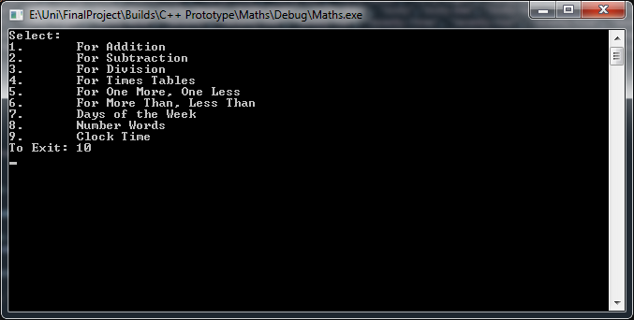

The first step was to create a menu system that can be used to take the user to the section that they want to work on. This is done by outputting a list of the sections that are available for the user to go through and asking the user to input their choice. It will take the value that is input and then call the function of their desired section. After this function is completed, they will be returned to the menu where the main function will be recalled, and they can select a new section from the list.

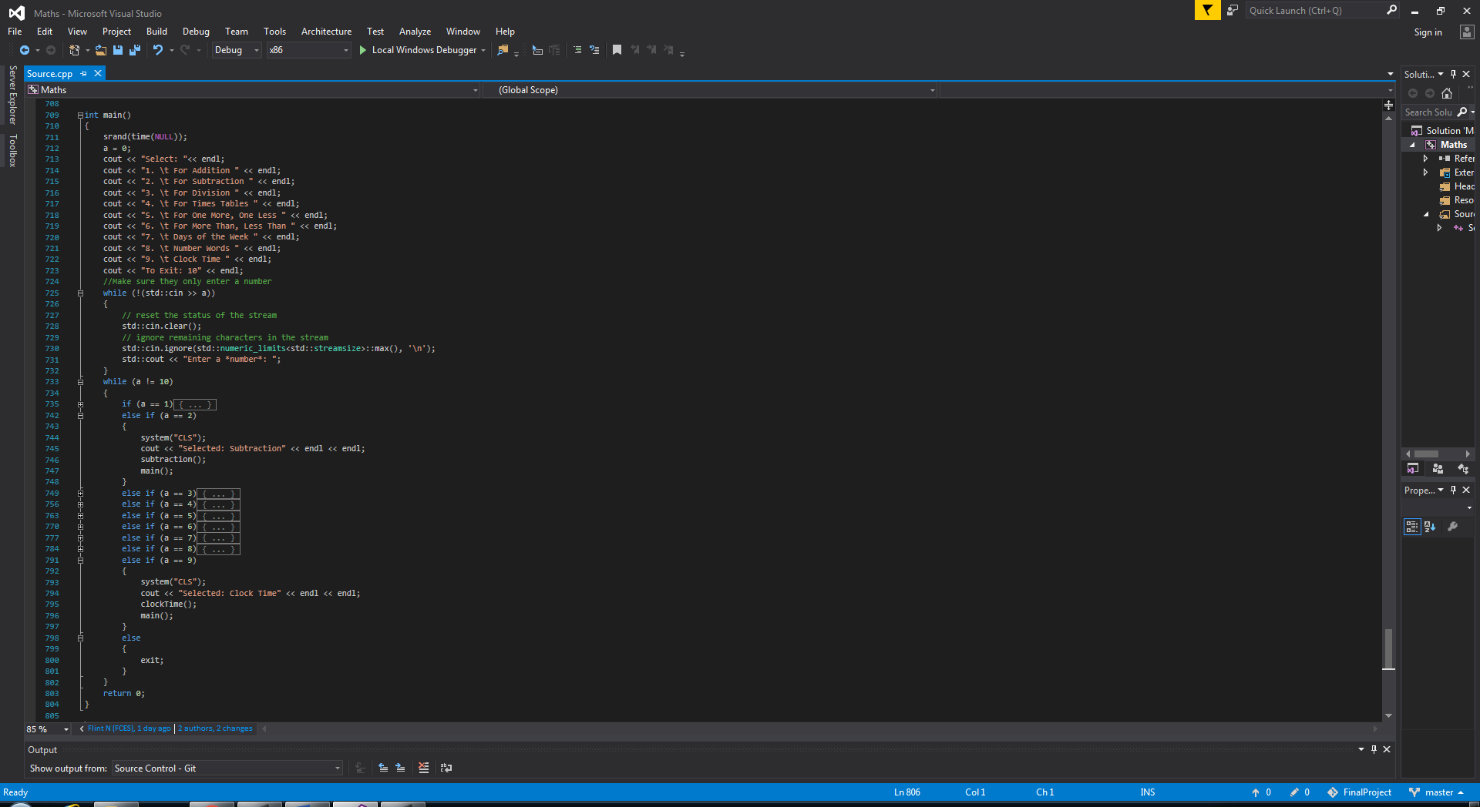

This is not an efficient method to use to handle this process, a much better version would be to use a finite state machine, but at this stage of development it was important to get a working variation of the code as quickly as possible so that time was not being taken away from developing within Unity that using a finite state machine was completely forgotten about until it got to the point where 8 of the sections were created, but at that point the decision was made to leave it like this but make sure that a finite state machine is used within Unity and the final prototype. In Unity, there will be around 40 sections, ~20 for each year group, so it will be vital that a finite state machine is used to control the transitioning for each section. If the Unity version was handled similarly to that of the Visual Studio, it could experience a lot of memory leaks and even cause the program to run slower.

This prototype version was created so that if a user gets correct or incorrect it will tell them either way and then it will immediately display the correct answer before giving them a score for the number of questions they have got right so far. Once the user has finished answering all of the problems within a section all of the questions and correct answers are displayed for the user to view. Using the wait function from ICANSEEYOU7687 (2009) the application waits for 5 seconds and then returns the user to the menu. When the program returns to the menu it runs ‘system("CLS");’ to clear the console, this also happens when each section is run so that the console does not become cluttered with a lot of text.

The sections that were implanted within C++ were:

* Addition
* Subtraction
* Division
* Time Tables
* One More One Less
* More Than Less Than
* Days Of The Week
* Number Words
* Clock Time

#### 4.3.1 Addition, Subtraction, Division, Times Tables

Addition works by generating two random numbers from 0 to 100 and calculating the answer when they are added together, which are stored in separate arrays for later. The question is then displayed waiting for the user to answer and when they input their answer it is checked against the correct answer. If the value they input is correct, it lets the user knows they were right and repeated the correct answer to them; they are also awarded a point. If their guess was wrong, then they are told they were incorrect before the correct answer is displayed for them. This process repeats for ten questions, and at the end, all of the questions are repeated also showing the correct answers before the user is returned to the menu.

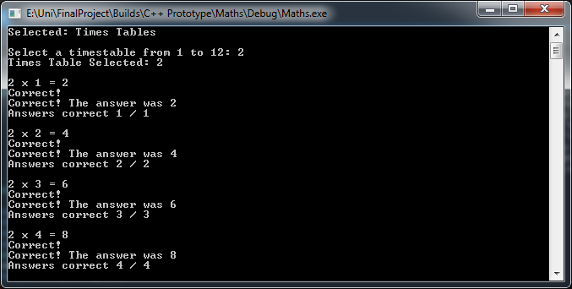

This process is the same for subtraction, division and the times tables. However, for subtraction, it makes sure that the larger value is always displayed first so that the question is asked correctly and that the answers will never be in the minus values. For the division at this stage in development, it was reverse engineered. The two variables generate a value from 1 to 12, one of these will be the answer that the user needs to find, and the other will be part of the question. These two values are then timed together to give the starting value for the question.

The question in C++ would read as: x = a*b; x / b = a;

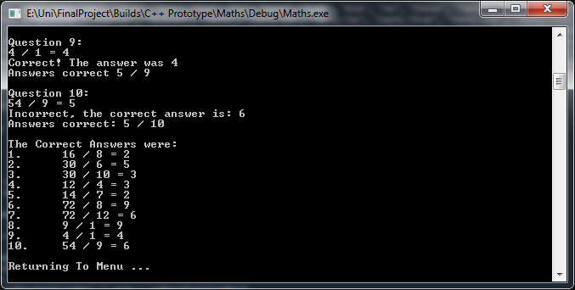

Having the question created in this method means that the values will always be divisible and never leave a remainder. An alternative approach would have been to generate two values from, e.g. 0 to 200 and have the larger divided by, the smaller. This would make it so there can be questions like 200 / 50 = 4, but it would also require an error check in place. This error check will need to make sure that when the two values are divided if the remainder left over is not equal to 0, then the values will need to randomise again till it comes up with a suitable pair. The method that has been chosen allows an appropriate question to be generated every time without requiring to use resources to check the values are adequate.

#### 4.3.2 One More One Less, More than Less than

One more, one less was created by having a random number generated from 1 to 99; the user is then asked what number is one more than that number, followed by the number that is one less. If they get the answer correct, they are awarded a point, but if they get the answer wrong, it displays the right answer for them.

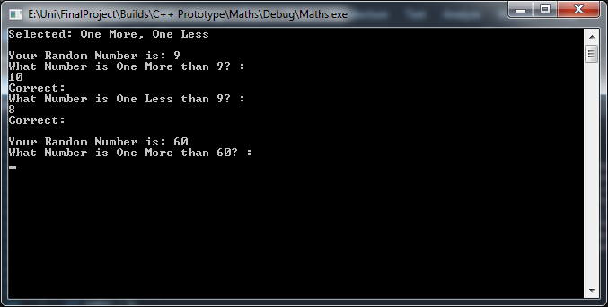

The more than, less than section was a bit more difficult as instead of comparing a number to a number it was changed to comparing strings which initially was a bit harder, but was soon overcome. In this section the user is asked to complete the statement using either the less than <, more than > or equals = symbols. This was done by having three strings which contained the symbols and then comparing their guess with the correct symbol for the statement. If they guessed the right symbol, it outputs the correct statement. In contrast, if they get it incorrect, it displays the correct symbol before outputting the full correct statement.

#### 4.3.3 Days of the Week, Number Words

For the days of the week and number words sections, both required two strings containing all of the variables. One that had the first letter capitalised and the other that was all lower case, as these sections are to test the spelling of the word and not initially if the user capitalises them.

For the days of the week, the user is asked for an example, "If tomorrow is [day name]. What day is it today?" This will also be changed to "if yesterday was…" and "if today is…". Here the user will be asked to input the day that they are choosing is the answer, to accept the answer both capitalised and all lower case the checking needs to be, if the answer they input is the same as either of the approved methods then they get the answer correct. However, when the answer is outputted to them, it will always be the capitalised version of the day.

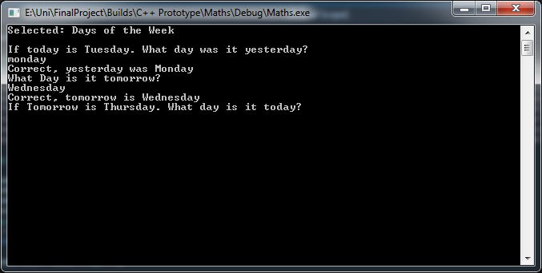

The number words section’s checking works in the same way. If the user is given the numerical value of a number and is asked to input the written version, it is compared against two versions of the sting from Jones (2018).

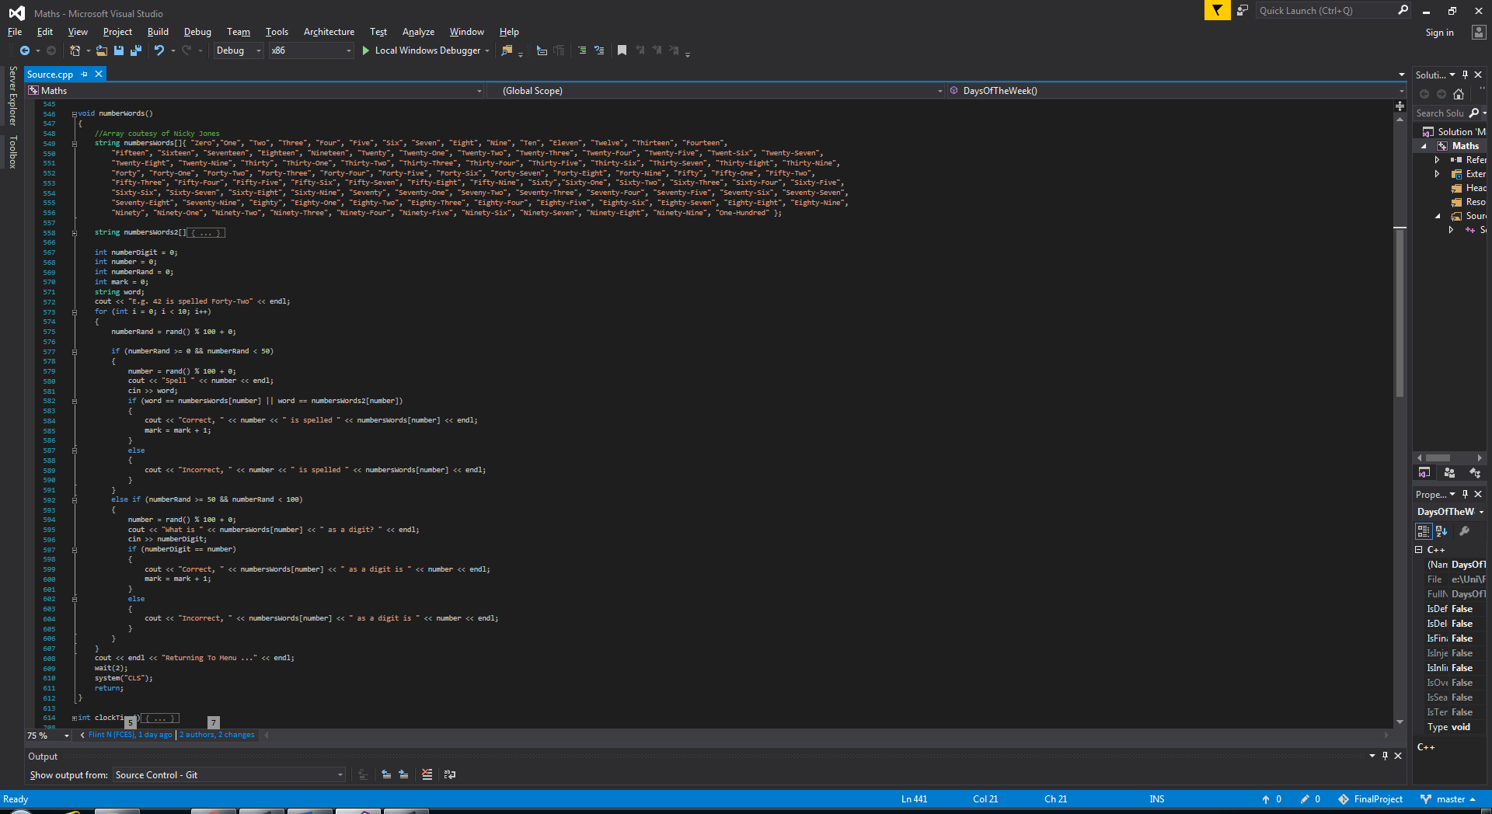

This section has 2 methods, either the user is given the numerical or written version of a number and is asked to provide the other version. As with the other sections the correct answer will always be given back to the user. The written version of the number will have the first letter capitalised.

#### 4.3.4 Clock Time

The questions for this section are more difficult than a year 2 student will be required to know, this asks for the answer to the minute, however, year 2 students will only need to know the time to every 5 minutes. Including O' Clock, Quarter Past, Half Past and Quarter To.

To calculate the time for the user to answer three variables are needed to be used. One is a random number from 1 to 12 which will represent the hours, another is the minutes which is a random number from 0 to 59, and the final will represent the time to the next hour which is 60 – minutes.

If the hour is equal to 2 and the minutes are equal to:

* 0 it displays that the time is 2 O’ Clock.
* 1 – 29 but not equal to 15 it shows that the time is, e.g. 26 past 2.
* 15 it says that the time is quarter past 2.
* 30 it means that the time is half past 3.
* 31 – 59 but not equal to 45 it says that the time is, e.g. 12 to 3.
* 45 it displays that the time is quarter to 3.

For each of these, the user is required to type the correct value for hours followed by the minutes. If the time is 6 past 3, they are not required to enter the 0 before the 6, but when the answer is outputted if the minutes is below 10, it will display it correctly with a 0 before the minutes.

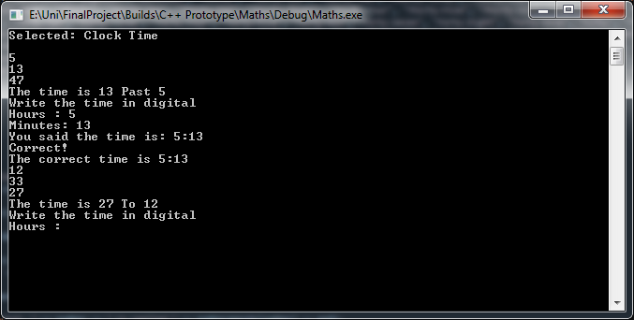

Having each of these sections created helped to give a reasonable basis for the method that would need to be used to create a similar outcome within Unity. Now that a way of programming the questions was produced it would make it easier to use them as references during the development of the Unity prototype.

# Chapter 5: Final Product

## 5.1 Initial Modifications to ‘Maths Challenge’ Asset

Within the ‘Maths Challenge' asset that has been used as a starting point for the application, there were a few things that initially needed to be changed to make it fit for the target audience. One of these being that the size of the variables, that are used to ask the questions needed to be reduced so that they are in keeping with the curriculum.

One change that was implemented straight away was that initially if the back button is pressed when in the process of answering questions it would keep track of the current score, even if the application is then switched and moved onto another section. Meaning that score is retained and can carry on with a full timer to accumulate more points. This has been changed so that if the game gets reset or the back button is pressed the score is set back to 0.

The asset was already making use of a state machine so that the ‘MathsController’ GameObject can keep track of which math type is in use so that it can display the correct images and text for the questions. This state machine will be built upon as it will make adding later sections easier to navigate through.

Deciding to take a step away from the ‘Maths Challenge' asset and developing a version in C++ with little or no guidance, as it was a familiar language gave the bonus of knowing completely what every single line of code was doing and why. This step was necessary as a lot of time was spent towards the beginning following tutorials, and then when it came to implementing prior knowledge into Unity, due to the learning curve that Unity possesses, there was a lot of time being spent with little to no progress to show for it.

## 5.2 Addition, Subtraction, Division, Multiplication and Times Tables

The functionality of the ‘Maths Challenge’ asset already contained sections for addition, subtraction, division, and multiplication. A copy of the multiplication section was created and modified to allow for a times table section. Depending on the times table that had been selected it changed the state to the one for the times tables and, rather than creating 12 separate functions to do the same code, just one variable is modified to suit the times table chosen.

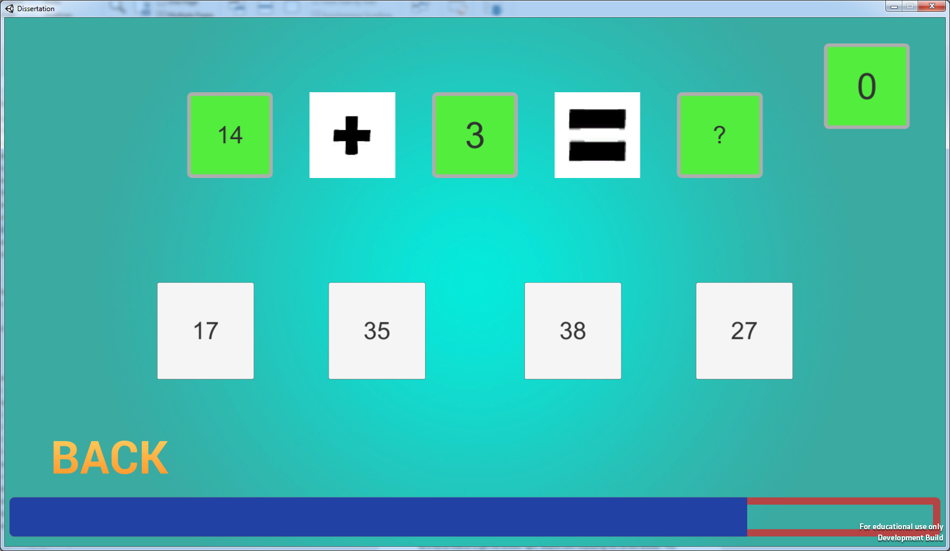

## 5.3 Duplicate Correct Answers

One recurring problem within development was that there was a chance of one of the incorrect answers being given the same text as the correct answer button, meaning it would be a 50/50 chance to get the answer right, despite both displaying the correct answer. This problem was fixed by making it so that if the wrong button displays the same as the correct button, the value is changed. This will stop 2 of the correct answer from showing up at once.

## 5.4 Input Fields

When it came to sections that were comparing text against numerical values, it was difficult to understand how to use Unity to take and save the inputs from input fields and compare them against an array which was storing the answers. Due to pressing time restraints, a decision was made to use button presses rather than keyboard input. It works so that the value generated by the question calls the corresponding space on the array list and that text is being displayed on the buttons, rather than having the children input text themselves.

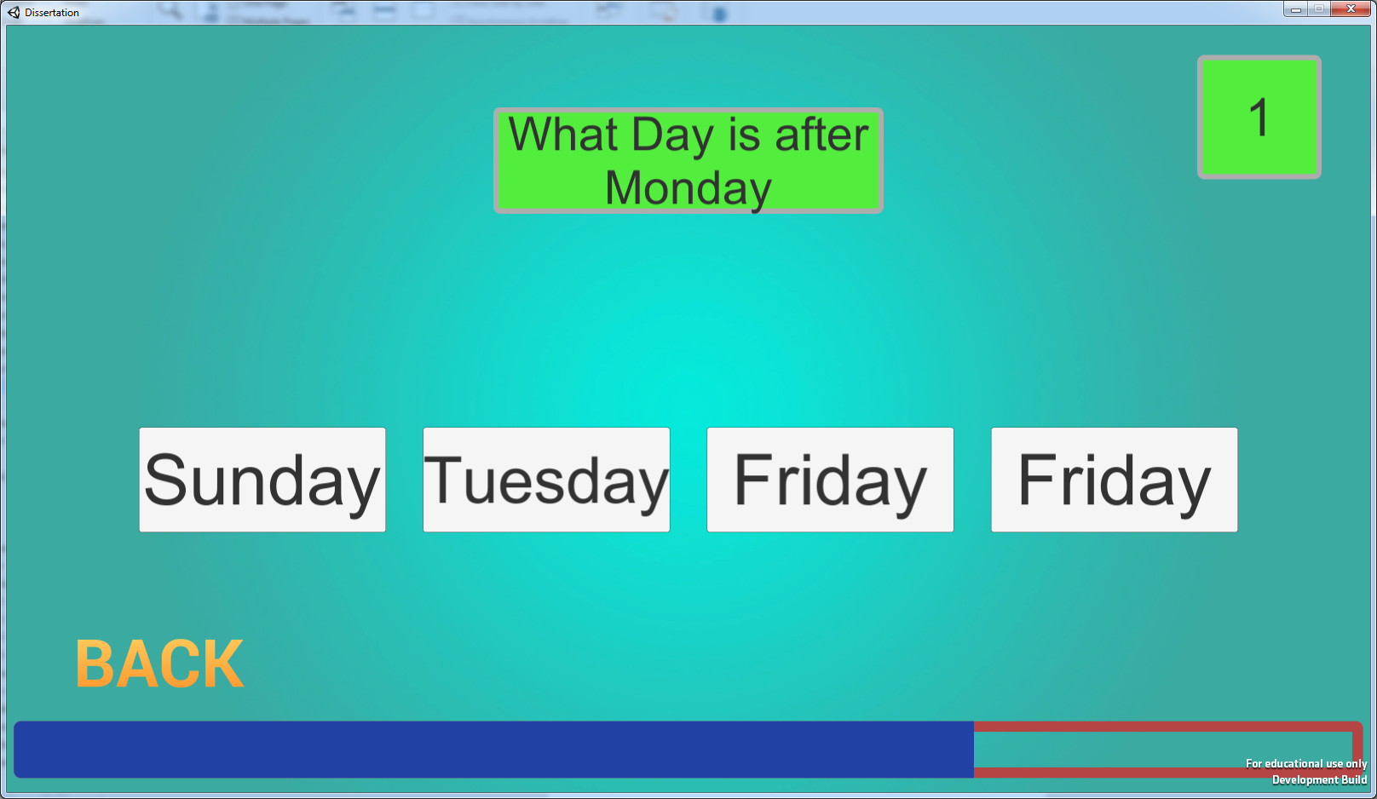

Another reason why it was decided to do button presses rather than using text input fields is that for student who is around 5 years of age, children cannot be expected to be able to type the correct spelling of a word within a time constraint, when they will only just be learning how to write the word down. In this sense, buttons are an acceptable alternative.

## 5.5 Number Words

The number words section works in a similar way to what it did in the C++ implementation, but instead of the user inputting the correct answer. Because of this change it would be beneficial to have it so that multiple versions of the correct number appear, but only one of which is spelt correctly, however for year 2 students, just recognising the exact numbers spelling would be difficult enough, but students of higher years may be required to spot the variation with the correct spelling.

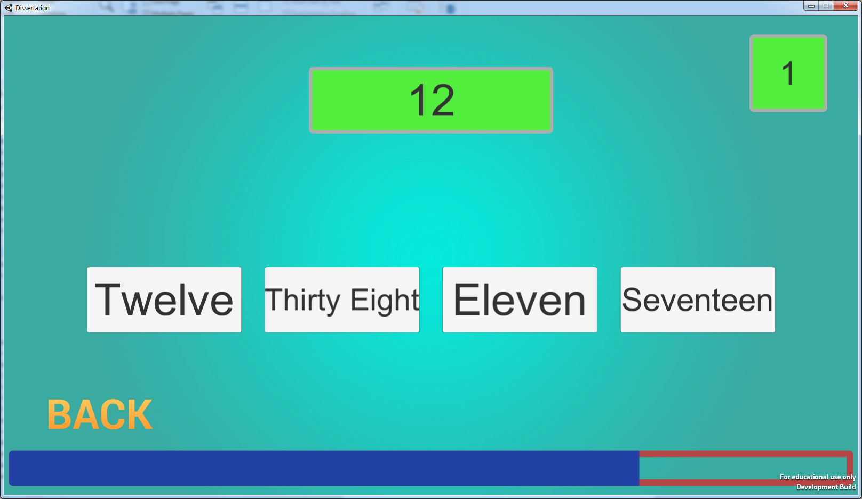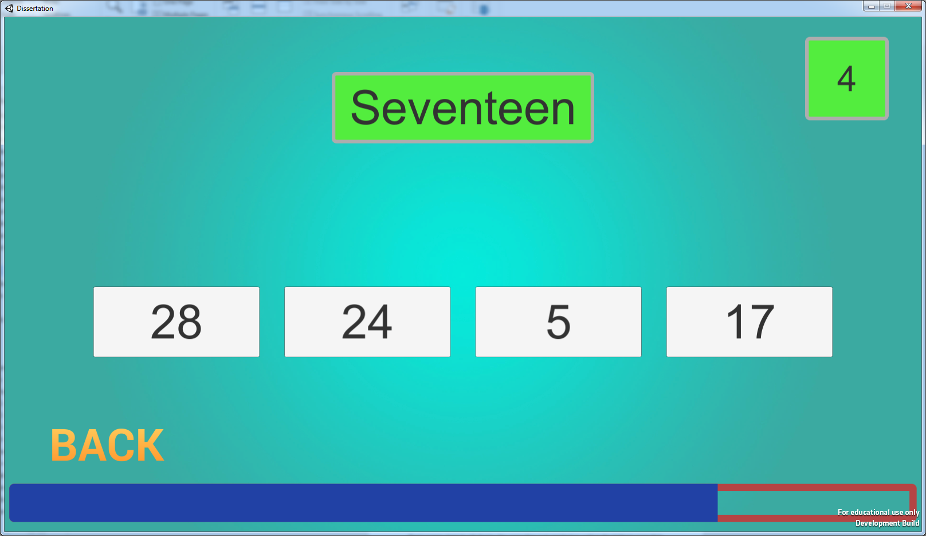

A lot of the final prototype works similarly to that of the C++ version, despite being changed to Button inputs. The questions have been scaled following the national curriculum so that they do not exceed what is required for the students to be able to answer.

When the user runs out of time to answer the questions they are presented with the ‘Game Over’ screen; here it will display the score they just reached as well as the highest score that they have achieved on a section.

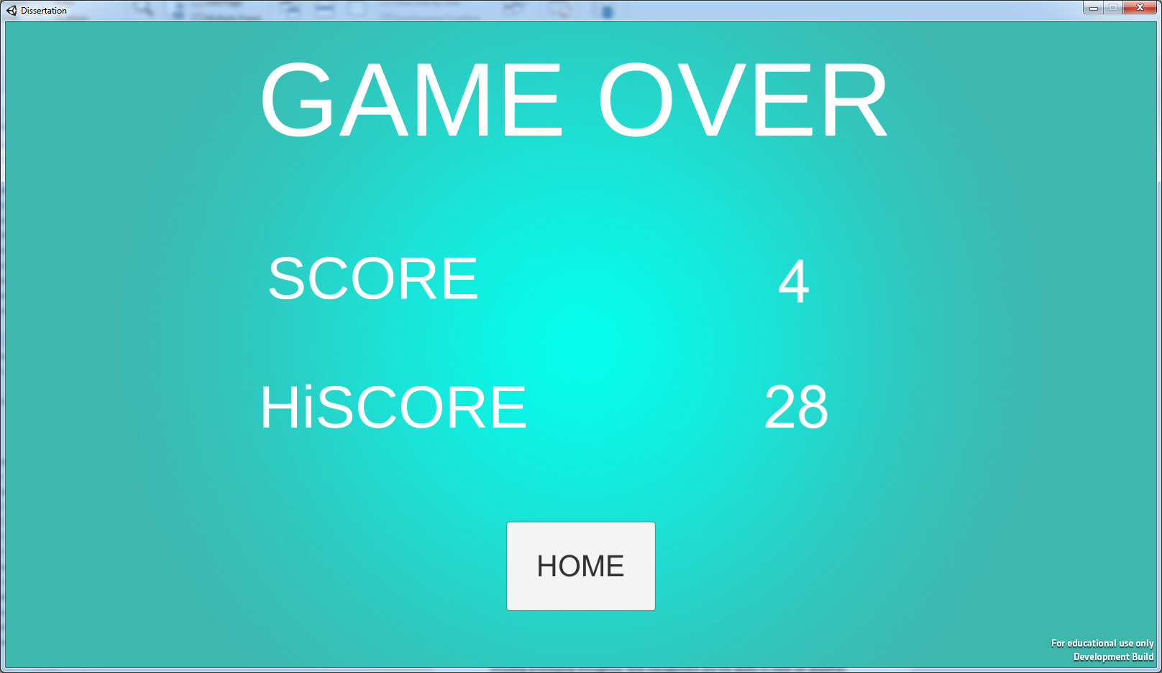

# Chapter 6: Critical Evaluation

When it comes to critically evaluating the project, it is essential to take into consideration the whole scope and not just the implementation. This includes the process of idea generation at the beginning and the initial development through to the final product. Including prototyping throughout, time management and the ability to meet set deadlines promptly. It is important to compare each of these aspects and reflect upon what could have been tackled differently and how.

At the beginning of the project, the objectives were set as a guideline to follow, indicating what was hoped to be achieved by the end. One of these objectives was to gain an understanding of the Unity Engine and the vast arsenal of tools that it has available for developers. Looking at the project as a whole, it is clear that the amount of knowledge that has been accumulated through the course of the project has vastly increased and is at a much higher level compared to the beginning.

One piece of knowledge that has been acquired throughout this project is the ability to use Unity’s UI systems to create an efficient menu. The menu is clear to use and is fit for the purpose presented by the project statement. The vibrant colours of the menu along with the size of the text are suited well for the use of Key Stage 1 children. For young children, the menu is simple to use, especially with the help of a teacher as this project should be used to assist in their learning. The sections of the project are well categorised making it easier for a child to find the section that they are going to learn from.

The simplistic style and the colour scheme that was chosen for the project are very well aimed at helping to keep children engaged with the application. This is because if it were cluttered and had an unappealing colour scheme, e.g. blue on dark blue, it would be harder for children to focus and stay engaged when using the application. Even though the menu could be made more fitting towards Key Stage 1 children with the addition of imagery tailored towards them, the use of animations within the application would have helped to increase the engagement of the children.

The 2nd and 3rd Project objectives were met from the outcome of the project, and this is because the end software that has been produced does cover the majority of the sections from the Key Stage 1 Curriculum for mathematics. Because of this, since each section has been tailored towards what the curriculum is expecting the students to learn it is therefore educational as well. However, the aspect that may not have been met by the project is that the product is not necessarily entertaining for children. This could be amended by adding fitting sounds and imagery to engage the users.

Where the point system fails to meet the requirements of the objective is that the project does not currently save the score per section, it is saved as a whole. Despite the point system being created by the asset that was used, from looking into the asset to work with it, it is easy to see how the scoring system has been implemented. This is shown in a similar way within the C++ prototype that was developed where the user would be awarded one point for every question that they got correct. The modification that would need to be made to allow this to meet the objective would be to have the high score local to the section and have it saved to separate text files so that the children could track their progress and improvements on a particular section, instead of losing their progress on one section as was overwritten by another.

The testing aspect fell short because even though a small range of around 15 people tested the product, they did not fall into the target audience. It is difficult to take data and responses from people aged 14 – 21 who say it would be suitable for children aged 4 – 7 without having testing on that age range to back it up. Although it is good to get responses to the colour scheme and complexity of the questions, it's very different from getting the target audience to test it and give their answers.

# Chapter 7: Conclusions

At the start of the project the idea of gamification within education was looked into, during this research it revealed that the more common ways that gamification has been introduced into the classroom are through verbal games, however, during the recent years, the idea of video game-based learning has begun to emerge more and more. As around 70% of schools within the UK has tablets that were being used for learning in 2014 (Coughlan) and the increasing amount of technologies that school children find themselves in contact with on a daily basis, the idea of Game-Based Learning has been increasing. The ideas of gamification and game-based learning have been the central focus during the development process of the project.

During this project, one of the things that have been learnt is how to use Unity and its tools. At the beginning of the project, there was very little knowledge of the Engine that was possessed. But from watching tutorials to expand understanding and then looking towards other pieces of work to see how they function, to reverse engineering an asset from the Unity Store, this has all helped to build the complexity of the project.

When comparing the first prototype menu which was made from following a tutorial, moving through to compiling a version of mathematics in a familiar language at the standard that could be used to teach school children, not taking into account the fact that it is text based, but just evaluating the functionality of the program. Then being able to take this and building upon someone else’s previous work to produce a more visually appealing version of the familiar code, while converting it into another language and working along with Unity's systems.

One of the objectives that was not met for the project was to be able to allow the children to keep track of their progress in each section. This is because every section uses the same score variables and always outputs the score to the same file. Because of this flaw in design it means that if a child gets, for example, a score of 10 on the addition section, that score will be saved in the file, but if they went and got a score of 15 in subtraction, the 15 score will overwrite the 10, meaning that the child cannot see if they make any progress on the addition stage even if they surpass their previous 10 score.

Due to a lack of time management towards the beginning of the project time was lost later down the line which has caused the application not to be as tailored towards keeping children engaged as initially stated as the outcome in the project objectives. This has resulted in the lack of imagery and animations. As found within the early research children are more engaging with visual representations that are captivating to them, it is easier to keep them engaged with pictures with animations and bright colours as compared to only having text on the screen. Despite the application functioning as intended by the objectives, it falls short due to this factor.

## 7.1 Future Works

One of the first steps that would be taken when continuing with the project will be to work on moving away from the foundations of the ‘Maths Challenge’ asset. The main reason for this is because of how the asset has been developed there is a chance that the user could experience multiple answers that show up that are the same, granted this has been fixed so that the answers which are duplicated will never be the same as the correct answer.

This is still a problem that will need to be fixed. Due to how the asset goes about the allocation of the values it does not use any variables to temporarily store the valued within so they can be checked against. Because of this, there is a chance, which is more apparent when working with a smaller amount of answers such as the Shapes and days of the week, that 2 or more of the buttons will all have the same text. It is possible to, as previously stated, to make sure that the value cannot be the same as the correct answer because the correct answer is stored in a variable.

The way that the asset works is to assign the correct answer to a button and then to fill the rest of the buttons with incorrect answers, because of this there is no room to check the wrong solutions against each other at this point.

The next improvement that will be made to the application is to have the 3D shapes within the application as 3D models, rather than images of 3D models. It would be a good idea to include this addition as it would be beneficial to the learning of the children to be able to rotate the 3D models and select either the vertices, edges or faces so that they can count them. As this is an aspect of the National Curriculum that was not met during this course of development, mostly due to lack of knowledge around the concept and time management causing this aspect not to be implemented.

My next step is to have different score variables for different sections so that each can have their high score saved so that the child that is using it knows how well they have previously done in that specific section.

# Chapter 8: Legal, Social, Ethical and Professional Issues

## 8.1 Legal

The legal issues that surround this project are the same that surround any computer-based company who are developing a digital product. They must make sure that they have the correct licences for the software that they are using. For example, the License for Unity Engine to publish and make revenue from projects made which is different to the student Licence that is being used for this project as this is not intended for commercial publication.

Another issue that computing projects could face is the Intellectual Property rights that surround assets that they could use. They would need to have the relevant permissions detailing how they are allowed to use the IP.

Visual Studio 2015 is software that is available to computing students through the Microsoft Imagine program, this program provides students with the Visual Studio program to complete their student work, as the work is done in this project was undergone as a student, and for research, this work is in keeping with Microsoft's Licence.

This factor was taken into account when it came to using assets from the Unity Store, one of the assets that has been used for the project, TextMeshPro, is now owned by Unity who have stated that the asset is free for all to use, including for commercial use with no other permission required. For another asset that has been used ‘Maths Challenge’ the creator has stated that the asset is free for all to use even for commercial use, however, contact to the developer was made, where permission to use the asset was granted, proof of permission can be found in Appendix 1.

## 8.2 Social

To make sure that the product is not seen to be tailored towards a specific gender the use of gender-neutral colour schemes as a default. If a feature was going to be added to change up the colour scheme that would be later on in production and would have a variety of schemes that are not necessarily aimed towards a single gender.

To combat any socioeconomic issues, this product will be designed to be used in the classroom as a large number of schools have access to tablets or laptops for students to use and learn from.

## 8.3 Ethical

One of the ethical issues that could be faced is the Data Protection Act of 1998 and the Human Rights Act of 1998, as a vast number of computer-based software has some storage on them, to battle this the information that would be stored from the final product of this project will not be used to store any data when the product is not in use, it will not store names or details of any fashion. The only data it will save is a high score which will be erased after the product has closed.

If any student data is to be gathered for constructive feedback to improve the product it will be completely anonymous and only for the intent of developing the product to make it suitable for the students, such as colour schemes, font size, sounds and appropriate imagery to make it more engaging for students.

Another issue is that if children are to test this product in any form, then correct measures will need to be taken to make sure the duty of care for the children is not affected in any way. As this is a product that is intended for child use it would need to be worded correctly so that they can coherently understand, it would be unsuitable to use wording and terminology that a child in the target audience would not be familiar with.

## 8.4 Professional Issues

As this is a research project and not set for where members of the public could gain access, it is difficult to foresee any professional issues that could arise with the project or the end deliverable.

# Chapter 9: Appendices

## 9.1 Appendix 1 – Project Timeline

### 9.1.1 Milestone 1 – 24/11/2017

* Get Unity Installed and become familiar with the UI and development tools
* Look into previously made games for classroom use.
* Look for and follow tutorials to get an idea of developing a game in unity
* Narrow down the sections of the Key Stage that will need to be developed
* Conduct background reading around the use and appliances of video games within the classroom.
* Have a basic main menu UI created as a base to start the Unity Development
* Have a list of all the questions and subject areas that will need to be included.

### 9.1.2 Milestone 2 – 02/02/2018

Prototype

* Have The menu UI completed to go to and from every section and exit
* Start, section by section implementing each of the question choices into the software
* Have a very basic graphical design for the software
* Implement a scoring system based on:
  + The time that is taken to complete the set of questions
  + Number of mistakes made
  + The difficulty of Questions answered
* Have a screen at the end of a question set showing in green the answers that are correct and those that are incorrect, and then display the correct answer.
* Have a local scoreboard on the device to see the score achieved
* Have details the whole way through in the development process.
  + Problems faced
  + Tasks completed
  + Resources used for guidance
* Have a different build number for each significant update in development, e.g. 1.0.1, 1.0.2, 1.1.0,
* Be working on graphical designs for the product.

### 9.1.3 Milestone 3 – 20/04/2018

* Consistently be adding to the report under the headings
  + Title Page
  + Statement of Originality
  + Abstract
  + Table of Contents
  + Introduction, Problem Statement, Objectives
  + Background Research
  + Methodology
  + Results
  + Critical Evaluation
  + Conclusions and Future Works
  + References
  + Appendices
  + Ethical, Legal, Social and Professional Issues
* Whether the objectives were met or how they changed throughout the project
* Source Code

### 9.1.4 Milestone 4 – 04/05/2018

* Presentation
* Poster

## 9.2 Appendix 1 – Proof of Permission for ‘Maths Challenge’ Asset

Proof of permission to use the ‘Maths Challenge’ from the Unity Asset Store from the developer as a starting point to build upon.

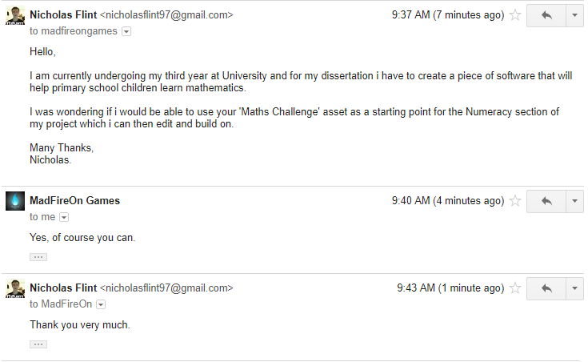

## 9.3 Appendix 2 – C++ Prototype Code

#include <iostream>

#include <time.h>

#include <string>

#include <limits>

#include <stdio.h>

using namespace std;

int q1 = 0;

int q2 = 0;

int ans = 0;

int guess = 0;

int mark;

int HighScore = 0;

int a = 0;

//Wait Function resource

//www.cplusplus.com/forum/beginner/15716/

//

void wait(int seconds)

{

clock_t endwait;

endwait = clock() + seconds * CLOCKS_PER_SEC;

while (clock() < endwait) {}

}

int addition()

{

//Variables for storing questions and answers

int ques1[10];

int ques2[10];

int answer[10];

int mark = 0;

//A for loop to work 10 times

for (int i = 0; i < 10; i++)

{

//Select 2 random Numbers

q1 = rand() % 100;

q2 = rand() % 100;

//Assign the numbers to the location of the array equal to i

//i is the number of times the loop has ran

ques1[i] = q1;

ques2[i] = q2;

//Calculate the answer

ans = q1 + q2;

//Output the question

cout << "Question " << (i + 1) << ": " << endl;

cout << q1 << " + " << q2 << " = ";

//A while to check that only numbers are being input

while (!(std::cin >> guess))

{

// reset the status of the stream

std::cin.clear();

// ignore remaining characters in the stream

std::cin.ignore(std::numeric_limits<std::streamsize>::max(), '\n');

std::cout << "Enter a *number*: ";

}

//If the answer is correct

if (ans == guess)

{

//Tell them that they are correct

//Give them a point

cout << "Correct! The answer was " << ans << endl;

mark = mark + 1;

//Show how many points they have got so far

cout << "Answers correct " << mark << " / " << (i + 1) << endl << endl;

answer[i] = ans;

}

else

{

//Tell them that they are not correct

//Tell them the correct answer

cout << "Incorrect, the correct answer is: " << ans << endl;

cout << "Answers correct: " << mark << " / " << (i + 1) << endl << endl;

answer[i] = ans;

}

}

//Output all of the correct answers

cout << "The Correct Answers were: " << endl;

cout << "1. " << "\t" << ques1[0] << " + " << ques2[0] << " = " << answer[0] << endl;

cout << "2. " << "\t" << ques1[1] << " + " << ques2[1] << " = " << answer[1] << endl;

cout << "3. " << "\t" << ques1[2] << " + " << ques2[2] << " = " << answer[2] << endl;

cout << "4. " << "\t" << ques1[3] << " + " << ques2[3] << " = " << answer[3] << endl;

cout << "5. " << "\t" << ques1[4] << " + " << ques2[4] << " = " << answer[4] << endl;

cout << "6. " << "\t" << ques1[5] << " + " << ques2[5] << " = " << answer[5] << endl;

cout << "7. " << "\t" << ques1[6] << " + " << ques2[6] << " = " << answer[6] << endl;

cout << "8. " << "\t" << ques1[7] << " + " << ques2[7] << " = " << answer[7] << endl;

cout << "9. " << "\t" << ques1[8] << " + " << ques2[8] << " = " << answer[8] << endl;

cout << "10. " << "\t" << ques1[9] << " + " << ques2[9] << " = " << answer[9] << endl;

//Returns to the main menu

//Clears the Screen

cout << endl << "Returning To Menu ..." << endl;

wait(2);

system("CLS");

return 0;

}

int subtraction()

{

int ques1[10];

int ques2[10];

int answer[10];

int mark = 0;

for (int i = 0; i < 10; i++)

{

q1 = rand() % 100;

q2 = rand() % 100;

if (q1 >= q2)

{

ans = q1 - q2;

cout << "Question " << (i + 1) << ": " << endl;

cout << q1 << " - " << q2 << " = ";

ques1[i] = q1;

ques2[i] = q2;

}

else

{

ans = q2 - q1;

cout << "Question " << (i + 1) << ": " << endl;

cout << q2 << " - " << q1 << " = ";

ques1[i] = q2;

ques2[i] = q1;

}

while (!(std::cin >> guess))

{

// reset the status of the stream

std::cin.clear();

// ignore remaining characters in the stream

std::cin.ignore(std::numeric_limits<std::streamsize>::max(), '\n');

std::cout << "Enter a *number*: ";

}

if (ans == guess)

{

cout << "Correct! The answer was " << ans << endl;

mark = mark + 1;

cout << "Answers correct " << mark << " / " << (i + 1) << endl << endl;

answer[i] = ans;

}

else

{

cout << "Incorrect, the correct answer is: " << ans << endl;

cout << "Answers correct: " << mark << " / " << (i + 1) << endl << endl;

answer[i] = ans;

}

}

cout << "The Correct Answers were: " << endl;

cout << "1. " << "\t" << ques1[0] << " - " << ques2[0] << " = " << answer[0] << endl;

cout << "2. " << "\t" << ques1[1] << " - " << ques2[1] << " = " << answer[1] << endl;

cout << "3. " << "\t" << ques1[2] << " - " << ques2[2] << " = " << answer[2] << endl;

cout << "4. " << "\t" << ques1[3] << " - " << ques2[3] << " = " << answer[3] << endl;

cout << "5. " << "\t" << ques1[4] << " - " << ques2[4] << " = " << answer[4] << endl;

cout << "6. " << "\t" << ques1[5] << " - " << ques2[5] << " = " << answer[5] << endl;

cout << "7. " << "\t" << ques1[6] << " - " << ques2[6] << " = " << answer[6] << endl;

cout << "8. " << "\t" << ques1[7] << " - " << ques2[7] << " = " << answer[7] << endl;

cout << "9. " << "\t" << ques1[8] << " - " << ques2[8] << " = " << answer[8] << endl;

cout << "10. " << "\t" << ques1[9] << " - " << ques2[9] << " = " << answer[9] << endl;

cout << endl << "Returning To Menu ..." << endl;

wait(2);

system("CLS");

return 0;

}

int division()

{

int ques1[10];

int ques2[10];

int answer[10];

int mark = 0;

for (int i = 0; i < 10; i++)

{

q1 = rand() % 12 + 1;

q2 = rand() % 12 + 1;

ans = q1 * q2;

cout << "Question " << (i + 1) << ": " << endl;

cout << ans << " / " << q2 << " = ";

ques1[i] = ans;

ques2[i] = q2;

while (!(std::cin >> guess))

{

// reset the status of the stream

std::cin.clear();

// ignore remaining characters in the stream

std::cin.ignore(std::numeric_limits<std::streamsize>::max(), '\n');

std::cout << "Enter a *number*: ";

}

if (q1 == guess)

{

cout << "Correct! The answer was " << q1 << endl;

mark = mark + 1;

cout << "Answers correct " << mark << " / " << (i + 1) << endl << endl;

answer[i] = q1;

}

else

{

cout << "Incorrect, the correct answer is: " << q1 << endl;

cout << "Answers correct: " << mark << " / " << (i + 1) << endl << endl;

answer[i] = q1;

}

}

cout << "The Correct Answers were: " << endl;

cout << "1. " << "\t" << ques1[0] << " / " << ques2[0] << " = " << answer[0] << endl;

cout << "2. " << "\t" << ques1[1] << " / " << ques2[1] << " = " << answer[1] << endl;

cout << "3. " << "\t" << ques1[2] << " / " << ques2[2] << " = " << answer[2] << endl;

cout << "4. " << "\t" << ques1[3] << " / " << ques2[3] << " = " << answer[3] << endl;

cout << "5. " << "\t" << ques1[4] << " / " << ques2[4] << " = " << answer[4] << endl;

cout << "6. " << "\t" << ques1[5] << " / " << ques2[5] << " = " << answer[5] << endl;

cout << "7. " << "\t" << ques1[6] << " / " << ques2[6] << " = " << answer[6] << endl;

cout << "8. " << "\t" << ques1[7] << " / " << ques2[7] << " = " << answer[7] << endl;

cout << "9. " << "\t" << ques1[8] << " / " << ques2[8] << " = " << answer[8] << endl;

cout << "10. " << "\t" << ques1[9] << " / " << ques2[9] << " = " << answer[9] << endl;

cout << endl <<"Returning To Menu ..." << endl;

wait(2);

system("CLS");

return 0;

}

int timestable()

{

int ques1[12];

int ques2[12];

int answer[12];

int mark = 0;

int times;

int guess;

cout << "Select a timestable from 1 to 12: ";

while (!(std::cin >> times))

{

// reset the status of the stream

std::cin.clear();

// ignore remaining characters in the stream

std::cin.ignore(std::numeric_limits<std::streamsize>::max(), '\n');

std::cout << "Enter a *number*: ";

}

cout << "Times Table Selected: " << times << endl << endl;

for (int i = 0; i < 12; i++)

{

cout << times << " x " << (i + 1) << " = ";

ans = times * (i + 1);

ques1[i] = times;

ques2[i] = i;

while (!(std::cin >> guess))

{

// reset the status of the stream

std::cin.clear();

// ignore remaining characters in the stream

std::cin.ignore(std::numeric_limits<std::streamsize>::max(), '\n');

std::cout << "Enter a *number*: ";

}

if (ans == guess)

{

cout << "Correct!" << endl;

cout << "Correct! The answer was " << ans << endl;

mark = mark + 1;

cout << "Answers correct " << mark << " / " << (i + 1) << endl << endl;

answer[i] = ans;

}

else

{

cout << "Incorrect, the correct answer is: " << ans << endl;

cout << "Answers correct " << mark << " / " << (i + 1) << endl << endl;

answer[i] = ans;

}

}

cout << "1. " << "\t" << ques1[0] << " x " << ques2[0] << " = " << answer[0] << endl;

cout << "2. " << "\t" << ques1[1] << " x " << ques2[1] << " = " << answer[1] << endl;

cout << "3. " << "\t" << ques1[2] << " x " << ques2[2] << " = " << answer[2] << endl;

cout << "4. " << "\t" << ques1[3] << " x " << ques2[3] << " = " << answer[3] << endl;

cout << "5. " << "\t" << ques1[4] << " x " << ques2[4] << " = " << answer[4] << endl;

cout << "6. " << "\t" << ques1[5] << " x " << ques2[5] << " = " << answer[5] << endl;

cout << "7. " << "\t" << ques1[6] << " x " << ques2[6] << " = " << answer[6] << endl;

cout << "8. " << "\t" << ques1[7] << " x " << ques2[7] << " = " << answer[7] << endl;

cout << "9. " << "\t" << ques1[8] << " x " << ques2[8] << " = " << answer[8] << endl;

cout << "10. " << "\t" << ques1[9] << " x " << ques2[9] << " = " << answer[9] << endl;

cout << "11. " << "\t" << ques1[10] << " x " << ques2[10] << " = " << answer[10] << endl;

cout << "12. " << "\t" << ques1[11] << " x " << ques2[11] << " = " << answer[11] << endl;

cout << endl << "Returning To Menu ..." << endl;

wait(5);

system("CLS");

return 0;

}

int OneMoreOneLess()

{

int mark = 0;

int ans = 0;

int oneMore = 0;

int oneLess = 0;

for (int i = 0; i < 10; i++)

{

ans = rand() % 99 + 2;

cout << "Your Random Number is: " << ans << endl;

cout << "What Number is One More than " << ans << "? : " << endl;

while (!(std::cin >> oneMore))

{

// reset the status of the stream

std::cin.clear();

// ignore remaining characters in the stream

std::cin.ignore(std::numeric_limits<std::streamsize>::max(), '\n');

std::cout << "Enter a *number*: ";

}

if (oneMore == ans + 1)

{

cout << "Correct: " << endl;

mark = mark + 1;

}

else if (oneMore < ans + 1 || oneMore > ans + 1)

{

cout << "Incorrect, the answer was " << (ans + 1) << endl;

}

else

{

cout << "Error!" << endl;

}

cout << "What Number is One Less than " << ans << "? : " << endl;

while (!(std::cin >> oneLess))

{

// reset the status of the stream

std::cin.clear();

// ignore remaining characters in the stream

std::cin.ignore(std::numeric_limits<std::streamsize>::max(), '\n');

std::cout << "Enter a *number*: ";

}

if (oneLess == ans - 1)

{

cout << "Correct: " << endl;

mark = mark + 1;

}

else if (oneLess > ans - 1 || oneLess < ans - 1)

{

cout << "Incorrect, the answer was " << (ans - 1) << endl;

}

else

{

cout << "Error!" << endl;

}

cout << endl;

}

cout << endl << "Returning To Menu ..." << endl;

wait(2);

system("CLS");

return 0;

}

int MoreThanLessThan()

{

int a = 0;

int b = 0;

string MoreThan = ">";

string LessThan = "<";

string EqualTo = "=";

string guess;

int mark = 0;

for (int i = 0; i < 10; i++)

{

a = rand() % 100 + 1;

b = rand() % 100 + 1;

cout << (i + 1) << "." << " Complete the statement" << endl;

cout << a << " " << b << endl;

cout << "Choose One: " << endl << "More Than: > " << endl <<"Less Than: < " << endl << "Equal To: = " << endl;

cin >> guess;

if (a > b)

{

if (guess == MoreThan)

{

cout << "Correct! The Full Statement Is: " << endl;

cout << a << " " << MoreThan << " " << b << endl;

mark = mark + 1;

}

else if (guess == LessThan || guess == EqualTo)

{

cout << "The Correct Answwer was" << MoreThan << endl;

cout << "The Full Statement Is: " << endl;

cout << a << " " << MoreThan << " " << b << endl;

}

else

{

cout << "An Error Occoured! " << endl;

}

}

else if (a < b)

{

if (guess == LessThan)

{

cout << "Correct! The Full Statement Is: " << endl;

cout << a << " " << LessThan << " " << b << endl;

mark = mark + 1;

}

else if (guess == MoreThan || guess == EqualTo)

{

cout << "The Correct Answwer was" << LessThan << endl;

cout << "The Full Statement Is: " << endl;

cout << a << " " << LessThan << " " << b << endl;

}

else

{

cout << "An Error Occoured! " << endl;

}

}

else if (a = b)

{

if (guess == EqualTo)

{

cout << "Correct! The Full Statement Is: " << endl;

cout << a << " " << EqualTo << " " << b << endl;

mark = mark + 1;

}

else if (guess == MoreThan || guess == LessThan)

{

cout << "The Correct Answwer was" << EqualTo << endl;

cout << "The Full Statement Is: " << endl;

cout << a << " " << EqualTo << " " << b << endl;

}

else

{

cout << "An Error Occoured! " << endl;

}

}

else

{

cout << "An Error Occoured! " << endl;

}

cout << "Current Score: " << mark << endl << endl;

}

cout << "Final Score: " << mark << endl;

cout << endl << "Returning To Menu ..." << endl;

wait(2);

system("CLS");

return 0;

}

void DaysOfTheWeek()

{

string WeekDays[]{ "Sunday","Monday", "Tuesday", "Wednesday", "Thursday", "Friday", "Saturday", "Sunday", "Monday" };

string WeekDays2[]{ "sunday", "monday", "tuesday", "wednesday", "thursday", "friday", "saturday", "sunday", "monday" };

string today;

string tomorrow;

string yesterday;

int mark = 0;

int day;

int x = 0;

for (int i = 0; i < 10; i++)

{

x = rand() % 100 + 1;

day = rand() % 7 + 1;

//Tomorrow

//Today

//Yesterday

if (x >= 1 && x < 33)

{

cout << "If Tomorrow is " << WeekDays[day + 1] << ". What day is it today? " << endl;

cin >> today;

if (today == WeekDays[day] || today == WeekDays2[day])

{

cout << "Correct, today is " << WeekDays[day] << endl;

mark = mark + 1;

}

else {

cout << "Incorrect, today is " << WeekDays[day] << endl;

}

cout << "What Day was it yesterday? " << endl;

cin >> yesterday;

if (yesterday == WeekDays[day - 1] || yesterday == WeekDays2[day - 1])

{

cout << "Correct, yesterday was " << WeekDays[day - 1] << endl;

mark = mark + 1;

}

else {

cout << "Incorrect, yesterday was " << WeekDays[day - 1] << endl;

}

}

//Yesterday

//Today

//Tomorrow

else if (x >= 33 && x < 67)

{

cout << "If Yesterday was " << WeekDays[day - 1] << ". What day is it today? " << endl;

cin >> today;

if (today == WeekDays[day] || today == WeekDays2[day])

{

cout << "Correct, today is " << WeekDays[day] << endl;

mark = mark + 1;

}

else {

cout << "Incorrect, today is " << WeekDays[day] << endl;

}

cout << "What Day is it tomorrow? " << endl;

cin >> tomorrow;

if (tomorrow == WeekDays[day + 1] || tomorrow == WeekDays2[day + 1])

{

cout << "Correct, tomorrow is " << WeekDays[day + 1] << endl;

mark = mark + 1;

}

else {

cout << "Incorrect, tomorrow is " << WeekDays[day + 1] << endl;

}

}

//Today

//Yesterday

//Tomorrow

else if (x >= 67 && x <= 100)

{

cout << "If today is " << WeekDays[day] << ". What day was it yesterday? " << endl;

cin >> yesterday;

if (yesterday == WeekDays[day - 1] || yesterday == WeekDays2[day - 1])

{

cout << "Correct, yesterday was " << WeekDays[day - 1] << endl;

mark = mark + 1;

}

else {

cout << "Incorrect, yesterday was " << WeekDays[day - 1] << endl;

}

cout << "What Day is it tomorrow? " << endl;

cin >> tomorrow;

if (tomorrow == WeekDays[day + 1] || tomorrow == WeekDays2[day + 1])

{

cout << "Correct, tomorrow is " << WeekDays[day + 1] << endl;

mark = mark + 1;

}

else {

cout << "Incorrect, tomorrow is " << WeekDays[day + 1] << endl;

}

}

else

{

cout << "An Error Occoured! " << endl;

}

}

cout << endl << "Returning To Menu ..." << endl;

wait(2);

system("CLS");

return;

}

void numberWords()

{

//Array coutesy of Nicky Jones

string numbersWords[]{ "Zero","One", "Two", "Three", "Four", "Five", "Six", "Seven", "Eight", "Nine", "Ten", "Eleven", "Twelve", "Thirteen", "Fourteen",

"Fifteen", "Sixteen", "Seventeen", "Eighteen", "Nineteen", "Twenty", "Twenty-One", "Twenty-Two", "Twenty-Three", "Twenty-Four", "Twenty-Five", "Twent-Six", "Twenty-Seven",

"Twenty-Eight", "Twenty-Nine", "Thirty", "Thirty-One", "Thirty-Two", "Thirty-Three", "Thirty-Four", "Thirty-Five", "Thirty-Six", "Thirty-Seven", "Thirty-Eight", "Thirty-Nine",

"Forty", "Forty-One", "Forty-Two", "Forty-Three", "Forty-Four", "Forty-Five", "Forty-Six", "Forty-Seven", "Forty-Eight", "Forty-Nine", "Fifty", "Fifty-One", "Fifty-Two",

"Fifty-Three", "Fifty-Four", "Fifty-Five", "Fifty-Six", "Fifty-Seven", "Fifty-Eight", "Fifty-Nine", "Sixty","Sixty-One", "Sixty-Two", "Sixty-Three", "Sixty-Four", "Sixty-Five",

"Sixty-Six", "Sixty-Seven", "Sixty-Eight", "Sixty-Nine", "Seventy", "Seventy-One", "Seveny-Two", "Seventy-Three", "Seventy-Four", "Seventy-Five", "Seventy-Six", "Seventy-Seven",

"Seventy-Eight", "Seventy-Nine", "Eighty", "Eighty-One", "Eighty-Two", "Eighty-Three", "Eighty-Four", "Eighty-Five", "Eighty-Six", "Eighty-Seven", "Eighty-Eight", "Eighty-Nine",

"Ninety", "Ninety-One", "Ninety-Two", "Ninety-Three", "Ninety-Four", "Ninety-Five", "Ninety-Six", "Ninety-Seven", "Ninety-Eight", "Ninety-Nine", "One-Hundred" };

string numbersWords2[]{ "zero","one", "two", "three", "four", "five", "six", "seven", "eight", "nine", "ten", "eleven", "twelve", "thirteen", "fourteen",

"fifteen", "sixteen", "seventeen", "eighteen", "nineteen", "twenty", "twenty-one", "twenty-two", "twenty-three", "twenty-four", "twenty-five", "twenty-six", "twenty-seven",

"twenty-eight", "twenty-nine", "thirty", "thirty-one", "thirty-two", "thirty-three", "thirty-four", "thirty-five", "thirty-six", "thirty-seven", "thirty-eight", "thirty-nine",

"forty", "forty-one", "forty-two", "forty-three", "forty-four", "forty-five", "forty-six", "forty-seven", "forty-eight", "forty-nine", "fifty", "fifty-one", "fifty-two",

"fifty-three", "fifty-four", "fifty-five", "fifty-six", "fifty-seven", "fifty-night", "fifty-nine", "sixty","sixty-one", "sixty-two", "sixty-three", "sixty-four", "sixty-five",

"sixty-six", "sixty-seven", "sixty-eight", "sixty-nine", "seventy", "seventy-one", "seventy-two", "seventy-three", "seventy-four", "seventy-five", "seventy-six", "seventy-seven",

"seventy-eight", "seventy-nine", "eighty", "eighty-one", "eighty-two", "eighty-three", "eighty-four", "eighty-five", "eighty-six", "eighty-seven", "eighty-eight", "eighty-nine",

"ninety", "ninety-one", "ninety-two", "ninety-three", "ninety-four", "ninety-five", "ninety-six", "ninety-seven", "ninety-eight", "ninety-nine", "one-hundred" };

int numberDigit = 0;

int number = 0;

int numberRand = 0;

int mark = 0;

string word;

cout << "E.g. 42 is spelled Forty-Two" << endl;

for (int i = 0; i < 10; i++)

{

numberRand = rand() % 100 + 0;

if (numberRand >= 0 && numberRand < 50)

{

number = rand() % 100 + 0;

cout << "Spell " << number << endl;

cin >> word;

if (word == numbersWords[number] || word == numbersWords2[number])

{

cout << "Correct, " << number << " is spelled " << numbersWords[number] << endl;

mark = mark + 1;

}

else

{

cout << "Incorrect, " << number << " is spelled " << numbersWords[number] << endl;

}

}

else if (numberRand >= 50 && numberRand < 100)

{

number = rand() % 100 + 0;

cout << "What is " << numbersWords[number] << " as a digit? " << endl;

cin >> numberDigit;

if (numberDigit == number)

{

cout << "Correct, " << numbersWords[number] << " as a digit is " << number << endl;

mark = mark + 1;

}

else

{

cout << "Incorrect, " << numbersWords[number] << " as a digit is " << number << endl;

}

}

}

cout << endl << "Returning To Menu ..." << endl;

wait(2);

system("CLS");

return;

}

int clockTime()

{

int hours = 0;

int minutes = 0;

int timeTo = 0;

int mark = 0;

int hourIn = 0;

int minuteIn = 0;

int zeroMin = 0;

string timeDesc[]{ " O'clock ", " Past ", " Quater Past ", " Half Past ", " To ", " Quater To " };

for (int i = 0; i < 10; i++)

{

hours = rand() % 12 + 1;

minutes = rand() % 59 + 0;

timeTo = 60 - minutes;

cout << hours << endl;

cout << minutes << endl;

cout << timeTo << endl;

if (minutes == 0)

{

cout << "The time is " << hours << timeDesc[0] << endl;

}

else if (minutes >= 1 && minutes <= 29 && minutes != 15)

{

cout << "The time is " << minutes << timeDesc[1] << hours << endl;

}

else if (minutes == 30)

{

cout << "The time is " << timeDesc[3] << hours << endl;

}

else if (minutes == 15)

{

cout << "The time is " << timeDesc[2] << hours << endl;

}

else if (minutes == 45)

{

cout << "The time is " << timeDesc[5] << hours << endl;

}

else if (minutes >= 31 && minutes <= 59 && minutes != 45)

{

cout << "The time is " << timeTo << timeDesc[4] << hours << endl;

}

cout << "Write the time in digital" << endl;

cout << "Hours : ";

while (!(std::cin >> hourIn))

{

// reset the status of the stream

std::cin.clear();

// ignore remaining characters in the stream

std::cin.ignore(std::numeric_limits<std::streamsize>::max(), '\n');

std::cout << "Enter a *number*: ";

}

cout << "Minutes: ";

while (!(std::cin >> minuteIn))

{

// reset the status of the stream

std::cin.clear();

// ignore remaining characters in the stream

std::cin.ignore(std::numeric_limits<std::streamsize>::max(), '\n');

std::cout << "Enter a *number*: ";

}

if (minuteIn >= 0 && minuteIn <= 9)

{

cout << "You said the time is: " << hourIn << ":" << zeroMin << minuteIn << endl;

}

else

{

cout << "You said the time is: " << hourIn << ":" << minuteIn << endl;

}

if (minutes >= 0 && minutes <= 9 && minuteIn == minutes && hourIn == hours)

{

cout << "Correct! " << endl;

cout << "The correct time is " << hours << ":" << zeroMin << minutes << endl;

mark = mark + 1;

}

else if (minutes >= 10 && minutes <= 59 && minuteIn == minutes && hourIn == hours)

{

cout << "Correct! " << endl;

cout << "The correct time is " << hours << ":" << minutes << endl;

mark = mark + 1;

}

else

{

cout << "Incorrect! " << endl;

cout << "The correct time is " << hours << ":" << minutes << endl;

}

}

cout << "Returning To Menu ..." << endl;

wait(2);

system("CLS");

return 0;

}

int main()

{

srand(time(NULL));

a = 0;

cout << "Select: "<< endl;

cout << "1. \t For Addition " << endl;

cout << "2. \t For Subtraction " << endl;

cout << "3. \t For Division " << endl;

cout << "4. \t For Times Tables " << endl;

cout << "5. \t For One More, One Less " << endl;

cout << "6. \t For More Than, Less Than " << endl;

cout << "7. \t Days of the Week " << endl;

cout << "8. \t Number Words " << endl;

cout << "9. \t Clock Time " << endl;

cout << "To Exit: 10" << endl;

//Make sure they only enter a number

while (!(std::cin >> a))

{

// reset the status of the stream

std::cin.clear();

// ignore remaining characters in the stream

std::cin.ignore(std::numeric_limits<std::streamsize>::max(), '\n');

std::cout << "Enter a *number*: ";

}

while (a != 10)

{

if (a == 1)

{

system("CLS");

cout << "Selected: Addition" << endl << endl;

addition();

main();

}

else if (a == 2)

{

system("CLS");

cout << "Selected: Subtraction" << endl << endl;

subtraction();

main();

}

else if (a == 3)

{

system("CLS");

cout << "Selected: Division" << endl << endl;

division();

main();

}

else if (a == 4)

{

system("CLS");

cout << "Selected: Times Tables" << endl << endl;

timestable();

main();

}

else if (a == 5)

{

system("CLS");

cout << "Selected: One More, One Less" << endl << endl;

OneMoreOneLess();

main();

}

else if (a == 6)

{

system("CLS");

cout << "Selected: More Than, Less Than" << endl << endl;

MoreThanLessThan();

main();

}

else if (a == 7)

{

system("CLS");

cout << "Selected: Days of the Week" << endl << endl;

DaysOfTheWeek();

main();

}

else if (a == 8)

{

system("CLS");

cout << "Selected: Number Words" << endl << endl;

numberWords();

main();

}

else if (a == 9)

{

system("CLS");

cout << "Selected: Clock Time" << endl << endl;

clockTime();

main();

}

else

{

exit;

}

}

return 0;

}

## 9.4 Appendix 3 - National Curriculum in England: Mathematics Programmes of Study

The following Headings and Bullet points have been taken directly from the Department for Education (2014) and underlie the National Curriculum in England for years 1 and 2, and these have been broken down into subheadings which will be made into the sections of the software that will be developed for this project.

### 9.4.1 Addition and Subtraction

Year 1

#### Addition, Subtraction

* read, write and interpret mathematical statements involving addition (+), subtraction (−) and equals (=) signs
* represent and use number bonds and related subtraction facts within 20
* add and subtract one-digit and two-digit numbers to 20, including 0
* Solve one-step problems that involve addition and subtraction, using concrete objects and pictorial representations, and missing number problems such as 7 = ? – 9

Year 2

#### Addition, Subtraction

* solve problems with addition and subtraction:
* using concrete objects and pictorial representations, including those involving numbers, quantities, and measures
* applying their increasing knowledge of mental and written methods
* recall and use addition and subtraction facts to 20 fluently, and derive and use related facts up to 100
* add and subtract numbers using concrete objects, pictorial representations, and mentally, including:
* a two-digit number and 1s
* a two-digit number and 10s
* Two two-digit numbers
* adding three one-digit numbers
* show that addition of 2 numbers can be done in any order (commutative) and subtraction of 1 number from another cannot
* recognise and use the inverse relationship between addition and subtraction and use this to check calculations and solve missing number problems

### 9.4.2 Multiplication and Division

Year 1

#### Multiplication, Division

* solve one-step problems involving multiplication and division, by calculating the answer using concrete objects, pictorial representations, and arrays with the support of the teacher

Year 2

#### Multiplication, Division, Times Table

* calculate mathematical statements for multiplication and division within the multiplication tables and write them using the multiplication (×), division (÷) and equals (=) signs
* show that multiplication of 2 numbers can be done in any order (commutative) and division of 1 number by another cannot
* solve problems involving multiplication and division, using materials, arrays, repeated addition, mental methods, and multiplication and division facts, including problems in contexts
* recall and use multiplication and division facts for the 2, 5 and 10 multiplication tables, including recognising odd and even numbers

### 9.4.3 Numbers and Place Values

Year 1

#### Place Values, One More, One Less, Number Words

* count to and across 100, forwards and backwards, beginning with 0 or 1, or from any given number
* count, read and write numbers to 100 in numerals; count in multiples of 2s, 5s, and 10s
* given a number, identify 1 more and 1 less
* identify and represent numbers using objects and pictorial representations including the number line, and use the language of equal to, more than, less than (fewer), most, least
* read and write numbers from 1 to 20 in numerals and words

Year 2

#### Place Values, More Than, Less Than, Number Words

* count in steps of 2, 3, and 5 from 0, and in 10s from any number, forward and backward
* recognise the place value of each digit in a two-digit number (10s, 1s)
* identify, represent and estimate numbers using different representations, including the number line
* compare and order numbers from 0 up to 100; use <, > and = signs
* read and write numbers to at least 100 in numerals and words
* use place value and number facts to solve problems

### 9.4.4 Fractions

Year 1

* recognise, find and name a half as 1 of 2 equal parts of an object, shape or quantity
* recognise, find and name a quarter as 1 of 4 equal parts of an object, shape or quantity

Year 2

* recognise, find, name and write fractions ,,  and  of a length, shape, set of objects or quantity
* write simple fractions, for example  of 6 = 3 and recognise the equivalence of  and 

### 9.4.5 Geometry - Shapes 2D/3D

#### Shapes: 2D, 3D, Mix

Year 1

Recognise and name common 2-D and 3-D shapes, including:

* 2-D shapes [for example, rectangles (including squares), circles and triangles]
* 3-D shapes [for example, cuboids (including cubes), pyramids and spheres]
* describe the position, direction, and movement, including whole, half, quarter and three-quarter turns

Year 2

#### Shapes: 2D, 3D, Mix

* identify and describe the properties of 2-D shapes, including the number of sides, and line symmetry in a vertical line
* identify and describe the properties of 3-D shapes, including the number of edges, vertices, and faces
* identify 2-D shapes on the surface of 3-D shapes, [for example, a circle on a cylinder and a triangle on a pyramid]
* compare and sort common 2-D and 3-D shapes and everyday objects
* order and arrange combinations of mathematical objects in patterns and sequences
* use mathematical vocabulary to describe the position, direction and movement, including movement in a straight line and distinguishing between rotation as a turn and in terms of right angles for a quarter, half and three-quarter turns (clockwise and anti-clockwise)

### 9.4.6 Measurement

Year 1

#### Measurements, Mass / Weight, Money, Time, Days of the Week

* compare, describe and solve practical problems for:
* lengths and heights [for example, long/short, longer/shorter, tall/short, double/half]
* mass/weight [for example, heavy/light, heavier than, lighter than]
* capacity and volume [for example, full/empty, more than, less than, half, half full, quarter]
* time [for example, quicker, slower, earlier, later]
* measure and begin to record the following:
* lengths and heights
* mass/weight
* capacity and volume
* time (hours, minutes, seconds)
* recognise and know the value of different denominations of coins and notes
* sequence events in chronological order using language [for example, before and after, next, first, today, yesterday, tomorrow, morning, afternoon and evening]
* recognise and use language relating to dates, including days of the week, weeks, months and years
* tell the time to the hour and half past the hour and draw the hands on a clock face to show these times

Year 2

#### Measurements, Mass / Weight, Money, Time, Days of the Week

* choose and use appropriate standard units to estimate and measure length/height in any direction (m/cm); mass (kg/g); temperature (°C); capacity (litres/ml) to the nearest appropriate unit, using rulers, scales, thermometers and measuring vessels
* compare and order lengths, mass, volume/capacity and record the results using >, < and =
* recognise and use symbols for pounds (£) and pence (p); combine amounts to make a particular value
* find different combinations of coins that equal the same amounts of money
* solve simple problems in a practical context involving addition and subtraction of money of the same unit, including giving change
* compare and sequence intervals of time
* tell and write the time to five minutes, including quarter past/to the hour and draw the hands on a clock face to show these times
* know the number of minutes in an hour and the number of hours in a day

## 9.5 Appendix 4 - Minutes of Meetings

### 9.5.1 Meeting 0 – 21/09/2017

* We confirmed the titles for our projects and then began to discuss how we think we should go about undergoing them and what we would like to get out as an end product.
* For the next project meeting we were asked to look up both Agile Development and Waterfall method as the university used to operate under the waterfall method, but this year we are given the option as to which version we want to operate around, based on which we find best suits us.
* We also looked at out timetables to discuss when would be best to have weekly meetings, and we decided on Mondays from 13:00 – 14:00 until the end of term 1 when our timetables change.

### 9.5.2 Meeting 1 – 25/09/2017

* During this meeting, we discussed in more detail the outlines of our project tasks. Nicky and I (as we have the same project title) asked whether our project is to be focused on the entirety of primary years, or whether we are just asked to focus on a particular Key stage of Learning.
* Andrew confirmed that we should more focus on one Key Stage. Thinking about this we realised that if we were going to tackle key stage 2 the product will need to be suitable for key stage 1 as well, so we agreed that it is better off us focusing on Key Stage 1.
* Next, Andrew suggested that we think about gamification and how we could make that fit in with our projects. And to come back to next week's meeting with a page or 2 detailing what we want to produce with screenshots either comparing it to existing pieces of work or showing how we want ours to look.
* During the next week, I made sure that I had Unity installed as this is the game engine I have decided to create my project in.

### 9.5.3 Meeting 2 – 02/10/2017

* Discussed how we want our projects to work when they are finished
* Started to consider as a group anything that could be done to help with that development.
* We discussed the background reading that we had done over the past week and Andrew advised that we should spend a few weeks getting used to the software that we have decided to use, which is Unity in all our cases, and follow some tutorials to get us started.
* It is better to spend a few weeks making little progress and learning the software, rather than to dive straight in and not have a clue how to use the software and get stuck.
* Throughout the next week, I have had a look at existing games that have been used to aid in the learning of Key Stage 1 children. Particularly on Cool Math-Games and BBC Bitesize.

### 9.5.4 Meeting 3 – 10/10/2017

* This meeting was rescheduled for the Tuesday rather than the agreed Monday.
* This was a smaller meeting as it had to take part during another of Andrew lessons as it was the only time that was suitable for everyone,
* Nicky was absent due to traffic as an accident had occurred on the roads.
* We discussed our progress over the previous week since our last meeting. I stated how I have been looking at existing maths games to gauge a trend, and I have been looking at C# tutorials that could potentially aid in the development of my project.
* Over the next week, I am going to narrow down the section of Key Stage 1 learning that will need to be tackled within my project and see if any Unity C# tutorials can give some assistance with getting a starting point in my project.

### 9.5.5 Meeting 4 – 16/10/2017

Absent from Meeting. An email of apology was sent, prior to the absence from the meting.

### 9.5.6 Meeting 5 – 23/10/2017

* During this meeting, I explained to Andrew that I was not planning on making much progress over the next week as my girlfriend was coming to visit and it was the only time I would be able to see her till Christmas.

### 9.5.7 Meeting 6 – 30/10/17

* As stated from last week's meeting I had done some work on the research and background reading for milestone 1, but besides that, not much progress in the form of development for my project was made.
* Nicky and Josh both showed a demo of the progress they had made so far.
* I stated to Andrew that I would be able to have a demo of the menu done for the next meeting.

### 9.5.8 Meeting 7 – 06/11/17

* I showed Andrew and the others my menu that I had created following a tutorial to use as a base. After this, I showed Andrew the method that I was thinking about using to create the times table aspect of my project. And I wanted to double check that he thought it was a useful method or if he could advise doing it another way.
* Andrew wanted us to discuss to make sure that we knew exactly what needed to be put into it and the final project.
* He was a bit shocked when we told him that our final project was not to exceed 10,000 words, as he said to us that they are usually 60 to 80 pages of content, whereas 10,000 words would only be around 20.
* He told us he would get back to us on the word count, but do not worry about the limit for now.

Some points that we were advised to keep in mind for our milestone 1 included:

* The information on why we’re going down the game route
* What work has been done on it previously
* And did it have any educational benefits
* Any reviews that have been conducted by the research
* We were told to find studies that have been made in the past for both sides
* For and against the use of using software to teach children, and to reference them accordingly
* Talk about where the projects or studies have succeeded or failed in the past so that we can work on that to make sure our project works well as intended.

### 9.5.9 Meeting 8 – 13/11/2017

Updates on our progress slowed down due to Milestone 1 hand in drawing closer

### 9.5.10 Meeting 9 – 20/11/2017

Updates on the development of milestone 1 as hand in are the end of the week

### 9.5.11 Meeting 10 – 27/11/2017

Talked about our milestone 1s and how we felt they went

### 9.5.12 Meeting 11 – 4/12/2017

Discussed how our projects are going and explained that we had a deadline at the end of the week and another the following week so work is being prioritised on them.

### 9.5.13 Meeting 12 – 11/12/2017

No meeting scheduled time was being prioritised for deadlines at the end of the week.

### 9.4.14 Meeting 13 – 15/01/2018

1st meeting after the Christmas Break, general updates

### 9.4.15 Meeting 14 – 22/01/2018

Andrew was told during the previous meeting that I would be absent from the meeting due to going home to celebrate my anniversary.

### 9.4.16 Meeting 15 – 29/01/2018

Showed off updated menu system and timetable code that I had written in C++ which I now need to convert to C# and implement in unity

### 9.4.17 Meetings after Milestone 2

After The submission of Milestone 2, the Meetings all followed the same theme. We would discuss the progress we had made or problems we encountered throughout the previous week of development.

We would then follow up with a discussion of how we are going to progress and what our aims for the next week were. After this, we would have a generalised conversation about the week ahead and how we were feeling with our other projects.

# Chapter 10: Ethics Checklist

This form is only applicable for assessed exercises that use other people (‘participants') for the collection of information, typically in getting comments about a system or a system design, or getting information about how a system could be used or evaluating a working system.

If your proposed activity does not comply with any one or more of the points below, then please contact your project supervisor and/or project coordinator for advice. If your evaluation does comply with all the points below, please sign this form and submit it with your assessed work.

1. Participants were not exposed to any risks greater than those encountered in their normal working life. *Investigators have a responsibility to protect participants from physical and mental harm during the investigation. The risk of harm must be no greater than in ordinary life. Areas of potential risk that require ethical approval include, but are not limited to, investigations that occur outside usual laboratory areas, or that require participant mobility (e.g. walking, running, use of public transport), unusual or repetitive activity or movement, that use sensory deprivation (e.g. ear plugs or blindfolds), bright or flashing lights, loud or disorienting noises, smell, taste, vibration, or force feedback.*
2. The experimental materials were paper-based, or comprised software running on standard hardware. *Participants should not be exposed to any risks associated with the use of non-standard equipment: anything other than pen-and-paper, standard PCs, mobile phones, and PDAs.*
3. All participants explicitly stated that they agreed to take part and that their data could be used in the project. If the results of the evaluation are likely to be used beyond the term of the project (for example, the software is to be deployed, or the data is to be published), then signed consent is necessary. A separate consent form should be signed by each participant. Otherwise, verbal consent is sufficient and should be explicitly requested in the introductory script.
4. No incentives were offered to the participants. The payment of participants must not be used to induce them to risk harm beyond that which they risk without payment in their normal lifestyle.
5. No information about the evaluation or materials was intentionally withheld from the participants. Withholding information or misleading participants is unacceptable if participants are likely to object or show unease when debriefed.
6. No participant was under the age of 16. Parental consent is required for participants under the age of 16.
7. No participant has an impairment that may limit their understanding or communication. Additional consent is required for participants with impairments.
8. Neither my supervisor nor I am in a position of authority or influence over any of the participants. A position of authority or influence over any participant must not be allowed to pressurise participants to take part in, or remain in, any experiment.
9. All participants were informed that they could withdraw at any time. All participants have the right to remove at any time during the investigation. They should be told this in the introductory script.
10. All participants have been informed of my contact details. All participants must be able to contact the investigator after the investigation. They should be given the circumstances of both student and module co-ordinator or supervisor as part of the debriefing.
11. The evaluation was discussed with all the participants at the end of the session, and all participants had the opportunity to ask questions. The student must provide the participants with sufficient information in the debriefing to enable them to understand the nature of the investigation.
12. All the data collected from the participants is stored in an anonymous form. All participant data (hard-copy and soft-copy) should be stored securely and in an unknown way.

Student Name: Nicholas Flint

Student ID: 15008134

Student’s Signature: N.Flint

Date: 10/11/17

# References

Anderson, M. A. (2000). It’s in the research. Library Talk, 13(1), 31-33.

BBC Bitesize, 2017. *BBC Bitesize.* [Online]   
Available at: https://www.bbc.co.uk/education  
[Accessed 23 November 2017].

Coughlan, S., 2014. *Tablet Compters in '70% of Schools'.* [Online]   
Available at: http://www.bbc.co.uk/news/education-30216408  
[Accessed 10 April 2018].

D’Angelo, C. et al., 2014. *Simulations for STEM Learning: Systematic Review and Meta-Analysis.* Menlo Park: SRI Education.

Department for Education, 2014. *National curriculum in England: mathematics programmes of study.* [Online]   
Available at: https://www.gov.uk/government/publications/national-curriculum-in-england-mathematics-programmes-of-study/national-curriculum-in-england-mathematics-programmes-of-study  
[Accessed 22 November 2017].

Doran, J., 2016. *Unity 5.x Game Development Blueprints.* Birmingham: Packt Publishing Ltd.

EducationWorld, n.d. *Teaching With Games.* [Online]   
[Accessed 23 November 2017].

Gray, P., 2012. *The Many Benefits, for Kids, of Playing Video Games.* [Online]   
[Accessed 23 November 2017].

Heafner, T., 2016. *Using Technology to Motivate Students to learn Social Studies.* [Online]   
Available at: http://www.citejournal.org/volume-4/issue-1-04/social-studies/using-technology-to-motivate-students-to-learn-social-studies/  
[Accessed 23 November 2017].

Herger, M., 2011. *Gamification Facts & Figures.* [Online]   
Available at: http://enterprise-gamification.com/index.php?option=com_content&view=article&id=41&Itemid=26&lang=en  
[Accessed 23 November 2017].

Hocking, J., 2015. *Unity In Action.* s.l.:Manning Publications Co..

ICANSEEYOU7687, 2009. *Making a Wait In Milliseconds Function.* [Online]   
Available at: http://www.cplusplus.com/forum/beginner/15716/  
[Accessed 29 January 2018].

Jones, N., 2018. *NumberWords String,* Pontypridd: s.n.

Kirriemuir, J. & McFarlane Angela, U. o. B., 2006. *Literature Review in.* Bristol: FutureLab.

Korbey, H., 2014. *Surprising Insights: How Teachers Use Games in the Classroom.* [Online]   
Available at: https://ww2.kqed.org/mindshift/2014/06/09/surprising-insights-how-teachers-use-games-in-the-classroom/  
[Accessed 23 November 2017].

Lavieri, E., 2015. *Getting Started with Unity 5.* Birmingham: Packt Publishing Ltd.

Lukosek, G., 2016. *Learning C# by Developing Games with Unity 5.x.* 2nd ed. Birmingham: Packt Publishing Ltd.

Mackay, R. F., 2013. *Playing to learn: Panelists at Stanford discussion say using games as an educational tool provides opportunities for deeper learning.* [Online]   
Available at: https://news.stanford.edu/2013/03/01/games-education-tool-030113/  
[Accessed 23 November 2017].

Malykhina, E., 2014. *Fact or Fiction?: Video Games Are the Future of Education.* [Online]   
Available at: https://www.scientificamerican.com/article/fact-or-fiction-video-games-are-the-future-of-education/  
[Accessed 23 November 2017].

MarketsAndMarkets, 2016. *Gamification Market by Solution (Consumer driven and Enterprise driven), Applications (Sales and Marketing), Deployment Type (On-Premises and Cloud), User Type (Large Enterprise, SMBs), Industry and Region - Global Forecast to 2020,* s.l.: Markets And Markets.

Microsoft, 2017. *Minecraft: Education Edition.* [Online]   
Available at: https://education.minecraft.net/  
[Accessed 23 November 2017].

Miller, A., 2011. *Game-Based Learning Units for the Everyday Teacher.* [Online]   
Available at: https://www.edutopia.org/blog/video-game-model-unit-andrew-miller  
[Accessed 23 November 2017].

Miller, J., 2014. *Microsoft pays $2.5bn for Minecraft maker Mojang.* [Online]   
Available at: http://www.bbc.co.uk/news/technology-29204518  
[Accessed 23 November 2017].

MinecraftEdu, n.d. *What is MinecradtEdu.* [Online]   
Available at: https://wiki.education.minecraft.net/wiki/What_is_MinecraftEdu  
[Accessed 23 November 2017].

Moursund, D., 2007. *Introduction to Using Games in Education: A Guide for Teachers and Parents,* s.l.: University of Oregon.

Mubaslat, M., 2012. *The Effect of Using Educational Games on the Students’ Achievement in English Language for the Primary Stage,* Jordan: s.n.

Sakamoto, T., n.d. *Present State of Videogames and Learning Games – Use and Effects,* Tokyo: s.n.

Shapiro, J., 2014. *Math, Science, History: Games Break Boundaries Between Subjects.* [Online]   
Available at: https://ww2.kqed.org/mindshift/2014/05/08/math-science-history-games-break-boundaries-between-subjects-interdisciplinary-learning/  
[Accessed 23 November 2017].

Sharpiro, J., 2014. *Games In The Classroom: What the Research Says.* [Online]   
Available at: https://ww2.kqed.org/mindshift/2014/06/27/games-in-the-classroom-what-the-research-says/  
[Accessed 23 November 2017].

Smith, M. & Queiroz, C., 2015. *Unity 5.x Cookbook.* Birmingham: Packt Publishing Ltd.

Smith-Robbins, S., 2011. "This Game Sucks": How to Improve the Gamification of Education. 7 February.

Squire, K., n.d. *Video Games In Education,* Cambridge: Massachusetts Institute of Technology.

Takeuchi, L. & Vaala, S., 2014. *Level up learning: A National Survey On Teaching with Digital games,* New York: The Joan Ganz Cooney Center.

TeacherGaming, 2017. *What is MinecraftEdu.* [Online]   
Available at: https://wiki.education.minecraft.net/wiki/What_is_MinecraftEdu  
[Accessed 23 November 2017].

Teed, R., 2016. *Game-Based Learning.* [Online]   
Available at: https://serc.carleton.edu/introgeo/games/index.html  
[Accessed 23 November 2017].

The Joan Ganz Cooney Center, 2016. *The Joan Ganz Cooney Center.* [Online]   
Available at: http://joanganzcooneycenter.org  
[Accessed 23 November 2017].

Thorn, A., 2016. *Unity 5.x By Example.* Birmingham: Packt Publishing Ltd.

United Kingdom Government, 1988. *United Kingdom: Human Rights Act 1998.* s.l.:s.n.

United Kingdom Government, 1998. *Data Protection Act 1998.* s.l.:The Stationery Office.

Wastiau, P., Kearney, C. & Van den Berghe, W., 2009. *How are Digital Games used in schools,* Belgium: European Schoolnet.

Wikipedia, 2017. *Bitesize.* [Online]   
Available at: https://en.wikipedia.org/wiki/Bitesize  
[Accessed 23 November 2017].

# Poster

